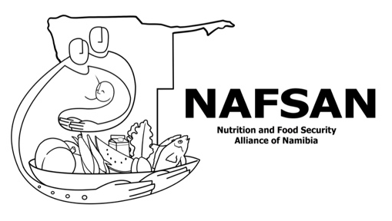
Application Form for Membership: Organizations

Organization Name: __________________________________________________________

Abbreviation of the Organization: ________________________________________

Organization Type: __________________________________________________________
Academic Institution / Civil Society Organization (Namibia) / Namibian Company (private sector) / Namibian Parastatal (state-owned enterprise) / Government Office, Ministry or Agency / International Organization / United Nations Organization

Email Address: ______________________________________________________________

Postal Address: ______________________________________________________________

Physical Address: ____________________________________________________________

____________________________________________________________

Phone Number: _____________________________________________________________

Email Address: ______________________________________________________________

Website (if applicable): _______________________________________________________

CONTACT PERSON:
Title [Mrs. / Ms. / Mr. / Dr. / Prof. / Hon.]: ______________

First Name(s): ______________________________________________________________

Surname: __________________________________________________________________

Role/Position: ______________________________________________________________

Phone: _____________________________ Cell: _________________________________

Email Address: ______________________________________________________________
AREA OF WORK:
Regions where the organization is active (please tick all applicable ones):
O Erongo O Hardap O Kavango East O Kavango West O Khomas
O Kunene O ǁKaras O Otjozondjupa O Ohangwena O Oshana
O Oshikoto O Omusati O Omaheke O Zambezi

Number of Staff/Volunteers (please tick, as applicable):
O 1-10 O 11-40 O 41-200 O 200+

Core Mandate and Focus Area of the Organization: (use extra page, if needed)

___________________________________________________________________________

___________________________________________________________________________

___________________________________________________________________________

___________________________________________________________________________

___________________________________________________________________________

___________________________________________________________________________

Projects and/or Activities related to Food and Nutrition Security: (use extra page, if needed)

___________________________________________________________________________

___________________________________________________________________________

___________________________________________________________________________

___________________________________________________________________________

___________________________________________________________________________

___________________________________________________________________________
In which of the following six Working Groups within Namibia's Food and Nutrition Security Coordination Structure (www.nafsan.org/nfns) are you interested? - you can select more than one!
O Nutrition - focusing on nutrition for mothers infants, young children and adolescence, managing severe malnutrition, overweight/obesity, nutrition for the elderly, micronutrients, nutrition in emergencies, and on clinical nutrition.
O Food Security - focusing on food production, food processing and fortification, food safety, standards and quality control, public health, food security in but not limited to emergencies, social protection and safety nets, and on agro business, trading and marketing.
O Water, Environment, and Sanitation - focusing on environment conservation, sanitation provision and management, water supply and management, and on WASH [Water, Sanitation and Hygiene] in emergencies
O Advocacy, Communication, and Social Mobilisation - focusing on the dissemination of the FNS Policy, advocacy, strengthening capacity for social and resource mobilisation, creating platforms for information sharing and networking to take action and inform policies, identifying and working with nutrition champions, and on developing communication and social mobilisation strategies for enhancing food and security in Namibia.
O Operation Research - focusing on periodic assessments and operational research, monitoring and evaluation, and on innovations and technologies.
O Integrated Data and Information Systems - focusing on food security and nutrition surveillance systems, early warning systems, data quality, storage, and maintenance, data dissemination.

ADDITIONAL DOCUMENTS – required!
- DECLARATION FORM (attached, see next page) - You must complete, sign, and send us the Declaration Form, together with your application.
- REGISTRATION or FOUNDING DOCUMENT – Please send us a copy (ideally certified) of a document that confirms that your organization exists as a legal entity.

- Organization’s LOGO - If available, please also send a logo (as high quality as possible) of your organization via email to: info@nafsan.org with the name of your organization as ‘subject header’ of this email.

I hereby confirm being authorized to submit this application on behalf of our organization:

______________________ ____________________________ _____________________
Date Name of Signatory Signature

