SUITABILITY OF MARAMA BEAN FLOUR TO FORMULATE (READY-TO-USE-THERAPEUTIC FOOD) RUTF: ASH CONTENT AND PHYSICO-CHEMICAL PROPERTIES.

THIS RESEARCH PROPOSAL SUBMITTED IN FULFILMENT FOR THE REQUIREMENTS
FOR THE HONOURS DEGREE
IN THE
DEPARTMENT OF FOOD SCIENCE AND TECHNOLOGY
FACULTY OF AGRICULTURE AND NATURAL RESOURCES
THE UNIVERSITY OF NAMIBIA
BY
Beverly Virginia Aebes
November 2017

Main Supervisor: Mr. Chinemba Samundengu (University of Namibia)
Co- Supervisor: Dr. Kameine Nantanga (University of Namibia)

ABSRACT

The ash content and physicochemical properties: bulk density (BD), dispersibility, water absorption capacity (WAC), swelling index (SI), water solubility index (WSI) and the oil absorption capacity (OAC) of Marama bean flour were determined. The ash content was found to be 3.1%, while BD was 0.7%, dispersibility 69.6%, OAC 126.8%, SI 126.8%, WAC 683.3% and WSI 5.9%. The R² values were 0.262, 0.517, 0.870, 0.979, 0.819, 0.463 and 0.468 respectively. Roasting time and temperature had no significant (P> 0.05) effect on the ash content, while temperature had a significant (P< 0.05) effect on the bulk density. Time and temperature combination had a significant (P< 0.05) effect on the dispersibility, OAC, SI, WAC and the WSI. Roasting time did not have a significant (P> 0.05) effect on the WAC and WSI, while roasting temperature had a significant (P< 0.05) effect on the WAC, SI and the WSI. Roasting Marama beans at 110˚ Cfor 20 minutes and 30 minutes increased the ash content and the dispersibility, while roasting at 150˚ C for 20 minutes and 30 minutes increased the SI and the WAC. Roasting at 130˚ C for 30 minutes increased the WSI. Therefore, roasting Marama beans at 130˚ C for either at 20minutes or 30 minutes may be suitable to formulate RUTF paste.

DEDICATION
This study is dedicated to my loving mother Thalita Oa-Eis, and to my lovely friend Josua Handuukeme, relatives and friends. Thank you so much for all the prayers, encouragements and making sure that failure was never an option for me.

ACKNOWLEDGEMENTS
My biggest gratitude goes to God almighty for all His blessings and for enabling to carry out this study. My sincere appreciation then goes out to the following people and the institutions for their utmost contribution in the course of the study.
- NSFA for providing the funds to make this study possible.
- My main supervisor, Mr. C. Samundengu, thank you very much for all the patience, guidance, supervision and wisdom.
- My co- supervisor, Dr. K. Nantanga, thank you for all the knowledge, time, help and for encouraging me always to work hard.
- Mrs. W. Kanime, for her assistance with the laboratory work.
- Mrs. M. Van Wyk, Ministry of Health and Social Services, Department of Nutrition, for providing me with all the history of RUFT.
- Miss V. Charamba for all the guidance with statistical analysis.

DECLARATION
I, Beverly Virginia Aebes, hereby declare that this dissertation is my original work and it is herewith submitted for the Bachelor degree in Agriculture (Food Science and Technology) at the University of Namibia. This work has not been submitted to any other university or institution of higher education.

………………………….. ………………………….
Beverly Virginia Aebes Date

Acronyms
ANOVA Analysis of Variance
BD Bulk density
OAC Oil absorption capacity
RUTF Ready- to- Use- Therapeutic Food
SI Swelling index
WAC Water absorption capacity
WSI Water solubility index

Table of content
Contents
ABSRACT 2
DEDICATION 3
ACKNOWLEDGEMENTS 4
DECLARATION 5
Acronyms 6
CHAPTER 1 10
INTRODUCTION 10
1.1 Background 10
1.2 Statement of research problem 12
1.3 Objectives 13
1.4 Specific objectives 13
1.5 Hypothesis 13
1.6 Significance of the study 13
1.7 Limitations of the study 14
CHAPTER 2 15
LITERATURE REVIEW 15
2.1 General Marama plant information 15
2.2 Nutritional content of seeds 15
2.3 Uses of seeds 16
2.4 Nutritional and organoleptic changes when processing seeds such as Marama 17
2.5 Roasting of marama beans 17
2.6 The storage of Marama beans 17
2.7 Review of value addition research on Marama seed 18
2.8 Economic importance of marama beans 18
2.9 Domestication of marama beans 18
2.10 Malnutrition 19
2.10.1 Malnutrition worldwide 19
2.10.2 Malnutrition in Namibia 20
2.11 RUTFs 20
2.12 Ash content of Marama bean flour 21
2.13 Physicochemical properties of Marama bean flour 21
2.13.1 Bulk density (BD) 21
2.13.2 Dispersibility 22
2.13.3 Swelling index (SI) 22
2.13.4 Water absorption capacity (WAC) 22
2.13.5 Oil absorption capacity (OAC) 23
2.13.6 Water solubility index (WSI) 23
CHAPTER 3 24
METHODOLOGY 24
3.1 Research design 24
3.2 Roasting Marama beans 24
3.3 Decorticating Marama beans 25
3.4 Milling 25
3.5 Determination of ash content 25
3.6 Physicochemical properties 26
3.6.1 Determination of bulk density 26
3.6.2 Determination of dispersibility 26
3.6.3 Determination of oil absorption capacity 27
3.6.4 Determination of water absorption capacity 27
3.6.5 Determination of water solubility index 28
3.6.6 Determination of swelling index 28
3.7 Data analysis 29
CHAPTER 4 30
RESULTS 30
4.1 Ash content 31
4.2 Bulk density (BD) 32
4.3 Dispersibility 32
4.4 Swelling index (SI) 33
4.5 Oil absorption capacity (OAC) 34
4.6 Water absorption capacity (WAC) 35
4.7 Water solubility index (WSI) 35
Chapter 5 38
Discussion 38
5.1 Ash content 38
5.2 Physicochemical properties 38
5.2.1 Bulk density (BD) 38
5.2.2 Dispesibility 38
5.2.3 Swelling index (SI) 39
5.2.4 Oil absorption capacity (OAC) 39
5.2.5 Water absorption capacity (WAC) 39
5.2.6 Water solubility index (WSI) 40
CHAPTER 6 41
CONCLUSION AND RECCOMMENDATIONS 41
6.1 Conclusion 41
6.2 Recommendations 41
References 42
Appendices 47

CHAPTER 1

INTRODUCTION

1.1 Background
The marama bean (Tylosema esculentum) is a long- lived lasting species. According to Kapewangolo (2010) the word esculentum means edible. It is a drought resistant legume that naturally grows in large populations (Museler and Schonfeldt, 2006 and Chimwamurombe, 2011). Marama bean is classified in the Leguminosae family and the Caesalpinoideae subfamily (Kapewangolo, 2010).

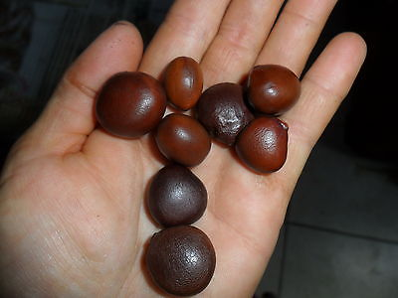
Figure 1. Marama beans (Maruatona, Duodu and Minnar, 2010).
Marama beans are commonly found in the arid areas of Southern Africa, specifically in Botswana (around Kgalagadi region), Namibia and smaller populations in the provinces of Limpopo, North- West and Gauteng in South Africa (Maruotona, 2008). In Namibia Marama beans are called different names depending on the different regions where it is found and the language that the people in that area speak. According to Chimwamurombe (2014) the indigenous plant is also known as gemsbok bean in English, marama or morama in Tswana, maramaboontjie, elandsboontjie and braaiboontjie in Afrikaans, maramama in Thonga, tsi-tsin in !Kung, gami in Khoi and ozombanui in the Herero language.

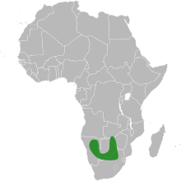
Figure 2. Countries in green are where Marama bean is found (Dakora, 2013).

Uncooked Marama beans are never eaten raw because they are tasteless and have an unpleasant slimy texture. The beans are normally roasted in sand by local people prior to consumption and after roasting the seeds take a nutty flavour that is comparable to that of roasted cashew nuts.
The seeds potential as a nutritional crop results from the high oil and protein content of the seed. Above the ground Marama bean produces seeds that are competing with peanut and soybean in composition and nutritive value, and below the ground it produces a high- protein tubers much bigger than sugar beet and more nutritive than potato (Kapewangolo, 2010). According to Museler (2005), Marama beans contain high levels of protein, phosphorus, calcium, unsaturated fats, vitamin A, vitamin B₃, vitamin B₆, folic acid, vitamin B₁₂ , iron, zinc and iodine.
Malnutrition is defined by the World Family Tree (WFT) as “a state in which the physical function of a person is reduced to the point where he or she can no longer maintain acceptable performance process such as growth, pregnancy, lactation, physical work and resisting and recovering from disease.” Malnutrition in other words simply means “bad nutrition” and this includes both over and under nutrition (Wagh and Doere, 2015). Museler (2005) stated that the causes underlying most nutritional problems around the world have not changed very much over the past 50years. Nevertheless, the author state that the approaches attempting malnutrition have changed, becoming multi- pronged for example coalescing supplementation programmes with nutritional food fortification and following food- based approaches in extension programmes. Ready-to-Use Therapeutic Foods (RUTFs) is the treatment option that is used to treat malnutrition in children, which is a nutrient and energy dense food that require no additional preparation before consumption (Bechman, 2008)
Wagh and Doere (2015), states that therapeutic foods are defined as foods that are aimed for specific, usually nutritional, therapeutic purposes as a practice of dietary supplement. RUTF is a mixture that is made up of nutrients that are aimed and primarily addressed to the treatment of the severe acute malnutrition with no difficulties. The formulation is made out of powdered milk, peanuts butter, vegetal oil, sugar, and a mix of vitamins, salts, and minerals. According to Bechman (2008), and Manary (2006) RUTF was made in Malawi using the same ingredients as PlumpyNut®, using a bakery mixer and then hand filling the product in plastic containers to keep the production cost low.
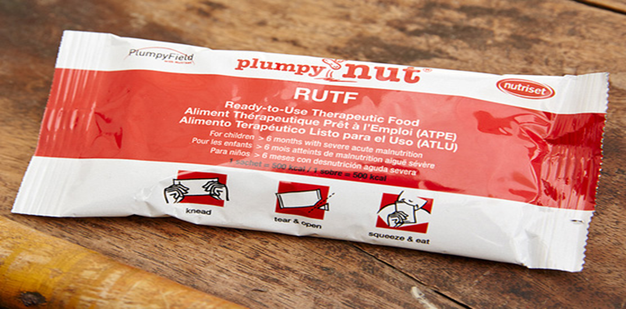
Figure 3. RUTF (Wagh and Doere, 2015).

1.2 Statement of research problem
Marama bean have a potential of becoming a nutritional crop because of the high oil and protein content of its seed and it also has potential for use in human health. In Namibia, Marama bean still remains an underutilized plant. Marama beans protein content range is 34-37% on dry basis (Museler and Schonfelt, 2006) and it is comparable to that of soybeans which is 43% (Muruatona, 2008). Therefore, according to Dakora (2013), the potential of the Marama bean is high to substitute the soybean as a protein source, after genetical improvements have been made. It also has 37-39% crude fat, 19% carbohydrate and 3-3.2% (Museler and Schonfelt, 2006). With this nutrient composition, Marama bean has potential to contribute to the alleviation of malnutrition. In Namibia, there is a high rate of malnutrition (Museler, 2005). Marama has been composited with sorghum and the effect of roasting of marama on the nutritional quality and antioxidant properties of the marama-sorghum flours and porridges have been determined (Kayitesi, L. de Kock, Minnar & Duodu, 2011). There is little or no literature that has looked at the physicochemical properties of roasted Marama beans to formulate RUTF. Therefore, to contribute to an improved utilization of Marama, this study will investigate the effect of roasting Marama bean on the ash and physicochemical properties to formulate RUTF.

1.3 Objectives
The overall objective of this study is to determine the suitability of Marama bean flour (ash content and physicochemical properties) to formulate RUTF.

1.4 Specific objectives
- To determine the effect of roasting temperature on the ash content and physico-chemical properties of Marama bean flour.
- To determine the effect of roasting duration on the ash content and physico-chemical properties of Marama bean flour.
- To assess the effect of roasting temperature and duration on the ash content and physico-chemical properties of Marama bean flour.

1.5 Hypothesis
H₀₁: Temperature of roasting undecorticated Marama beans does not have an effect on the ash content and physico-chemical properties of marama bean flour.
H₀₂: Duration of roasting undecorticated Marama beans does not have an effect on the ash content and physico-chemical properties of marama bean flour.
H₀₃: Temperature and duration of roasting undecorticated Marama beans does not have an effect on the ash content and physico-chemical properties of marama bean flour.

1.6 Significance of the study
Marama Bean is perhaps the least developed in terms of scientific study or plant breeding efforts to improve it (Echo Plant Information Sheet, 2016). Holse, Husted, and Hansen (2010) showed that a number of families hope to have the Marama bean as part of the commercial market in order to stabilize food security and improve food diversity. According to Chimwamurombe (2014) Marama has a huge potential to address the problem of hunger and malnutrition in the parched areas of Southern Africa. Due to its high protein and fat content, Marama bean have the potential to be used in human health. By adding value to Marama bean through processing into protein rich flours, its utilisation may be increased (Muruatona, 2008).This study aim to alleviate the problem of malnutrition in Namibia by using underutilised Marama bean to formulate RUTF.

1.7 Limitations of the study
The limitation of this study was the limited amount of time to formulate RUTF and to examine the effect of ash and physicochemical properties on the paste. The second limitation was the unavailability of the equipment to formulate the paste.

CHAPTER 2

LITERATURE REVIEW

2.1 General Marama plant information
According Kapewangolo (2010) in Namibia, the local people who eat marama beans are found in Okakarara and Gobabis, although, Chiwamurombe (2014) showed that in Namibia it grows wild mainly in Omaheke and Otjizondjupa regions. The seeds of Marama plant are collected by hand while the tubers are harvested by hand digging. The raw seeds of Marama can be stored and they remain edible for years and dry storage is preferable. (Kapewangolo,2010). According to Kapewangolo (2010), roasting of the beans is known to be one of the processing methods. Roasting increases the overall palatability and enhances the flavour, texture and appearance of the bean. Raw Marama bean heat treatments have an effect of reducing parameters such as moisture content of the bean.

2.2 Nutritional content of seeds
According to Kanamori et al (1982) and Vietmeyer (1986) as cited in Kapewangolo (2010), the fat and the protein in Marama beans are greater than in many other legumes as well as in many other potential crops. The Marama bean protein seems to be similar to soybean in essential amino acid content, with cysteine and methionine as the limiting amino acids (Kapewangolo, 2010). According to Gaamangwe (2008), the protein content of Marama beans ranges between 34 and 37% (dry basis) and it is comparable to that of soybeans, which is reported to be approximately 43% (Vaidehi and Kadam, as cited in Gaamangwe, 2008). There is a difference in the values of protein content of Marama beans reported and this is as a result of environmental factors such as the weather and the soil type. The most abundant proteins of Marama beans are, globulins are (53%), followed by albumins (23.3%), prolamins (15.5%), alkali soluble glutelins (7.7%), and acid soluble glutelins (0.5%), whereas , the soya bean proteins contain about 90% globulins and 10% albumins Gaamangwe, 2008). The oil content of marama bean is found to be 33.5- 39%, which is greater than that of soya beans (21%) but compares favourably with that of peanut (45.0- 55.0%). Although the moisture content may vary due to external factors, the moisture content of the bean is very low as the dry matter content ranges from 93.4- 98.7% (Bower, Hertel, Oh and Storey, 1988).

Bechman (2008) showed that cereals are the main source of calories in the diet in Sub- Saharan. Legumes are also available and when the two are combined in a 50: 50 ratio, a complete protein source is made. Kapewangolo (2010) demonstrated that the phytates found in Marama beans act as an anti- nutrient because they have the ability to bind to minerals and possibly reduce the assimilation of calcium, copper, iron, magnesium and zinc. Marama flour contains much higher tyrosine content (6.2 g/100 g flour) than soya bean flour (1.8 g/100 g flour). Chimwamurombe (2011) showed that the negative nutritional factor of the strong trypsin inhibition found in raw seeds can be averted by cooking.

2.3 Uses of seeds
Museler (2005) states that Marama seeds oil with unsaturated fatty acids can be use in cosmetics or as cooking oil. Chingwaru et al. (2011), showed that Marama bean have been use in the traditional African medicine to treat diarrhoea and for general upkeep of human health. Widely distributed secondary metabolites in the plant kingdom are known to be effective antagonists against viruses.
According to Powell (1987) as cited in Kapewangolo (2010), Marama beans are a potential source of phytonutrients as tannins, phytates, oligosaccharides which contribute to the health in particular prevention of non- communicable diseases such as cardiovascular diseases, diabetes and some cancers. Marama bean is also known to have cholesterol lowering effects in humans and this is contributed by the phytoestrogen content of the beans. The fibres in Marama beans helps the body get rid of bile in the liver, which could be converted to bile acids (Kapewangolo, 2010).
Creamy white water extracts that very similar to dairy milk or soymilk can be obtained from marama beans. Though it is not available commercially, the milk from the beans can be consumed in the form of a refreshing and nutritious beverage just like dairy milk or soymilk (Jackson et al., 2010). Maruatona, Duodu, and Minnaar (2010) and Chimwaramurombe (2014) showed that another marama bean product is its flour that has a potential as a functional food ingredient, and it is used to cereal flour for protein.
A potential list of prototype products has been produced from marama beans. The list of products includes marama cooking and salad oil, marama butter, snacks eaten at breakfast, meat analogues, marama roasted nuts, marama biscuits, cookies, muffins, bread and ice cream, and canned marama beans in tomato sauce.

2.4 Nutritional and organoleptic changes when processing seeds such as Marama
Maruotona (2008) demonstrated that the protein digestibility of Marama flour can be adversely affected by the trypsin inhibitors. The shelf life of the flour can be reduced by the presence of lipoxygenase enzymes. Whole Marama beans were dry heated at 100̊ C to inhibit the trypsin inhibitors. Trypsin inhibitor activity in its defatted flour is significantly reduced to almost zero by dry heating the whole Marama beans at 150˚ C/ 120min. According to Maruatona (2008) dry heating of the beans disrupt the lipid bodies of the bean allowing more oil to be expelled during the course milling of the flour. The vitro protein digestibility in Marama flour is significantly increased as a result of protein denaturation and the inactivation of the trypsin inhibitors. The heating of the beans decreased the amino acids content of Marama possibly due to the chemical modification of the amino acids. According to Maruatona (2008), due to heat treatment, there is a denaturation of the marama proteins which may potentially lead to the modification of the functional properties of protein rich flour as well as its protein quality. Protein related functional properties such as foaming, emulsification and water hydration capacity can negatively be affected due to the denaturation of the proteins. While on the other hand, the heat treatment of the proteins can also result in improved protein related functional properties and protein quality due to the unfolding of proteins, inactivation of the trypsin inhibitors and enzymes

2.5 Roasting of marama beans
In order to optimise dry heating to inactivate trypsin inhibitors in Marama beans, whole marama beans are dry heated at 100˚C, 120˚C and 150˚C respectively for 20mins (Muruatona, 2008). According to Jideani, Van Wyk and Cruywagen (2009) roasting Marama beans significantly increased the protein and the ash content. Roasting also increased the water absorption capacity and the oil absorption capacity.

2.6 The storage of Marama beans
Hase, Skov & Hansen (2012), conducted a study to evaluate the effect of packing roasted Marama beans in the presence or the absence of oxygen and storing them with or without exposure to light for seven months. During the storage period, the changes in the flavour related oxidation products were investigated, and it was found that roasted Marama beans should if possible be stored in dark bags containing a low amount of oxygen. The roasted Marama beans could also be stored for at least five months without obtaining undesirable odours caused by lipid oxidation under these conditions (Hase, Skov & Hansen, 2012). Marutora (2008) showed that marama oil is rich in mono and di- unsaturated fatty acids, that are vulnerable to oxidation of lipoxygenase enzymes and auto- oxidation which may lead to oxidation. As a result of this, the shelf life of Marama bean flour and/ or the nutritive value of the Marama bean may decrease.

2.7 Review of value addition research on Marama seed
As reported by the National Academy of Sciences, the Marama Bean is perhaps the least developed in terms of scientific study or plant breeding efforts to improve it (Echo Plant Information Sheet, 2016). According to Chimwamurombe (2011) despite its potential as a food and cash crop, very limited research has been done on Marama including research directed towards domestication. Bower and Hertel (1988) showed that the National Research Council in 1979 noted that Marama bean is a ignored legume of great potential. Adding value to marama bean through processing into protein- rich flours, its utilization may be increased.
Very little research efforts was also done on optimising post- harvest methods for dehulling and processing Marama beans into value added products such as protein- rich defatted Marama bean flours that can be used as functional ingredients in food systems (Museler, 2008). However, according to Kayitesi, L. de Knock, Minnaar and Duodu (2011), Marama bean have the potential to be used to enhance the nutritional quality of cereal products such as sorghum. Compositing sorghum with marama flour have the potential to provide better amino acid potential, increased protein content and energy value and could help alleviate protein energy malnutrition in developing countries.

2.8 Economic importance of marama beans
Marama bean contributes about 75% of the total vegetable content to the tribes in the Kalahari. The pleasant odour produced by the seeds can also be used to produce food while the, while some farmers use the Marama bean as a food supplement for fattening pigs (Chimwamurombe, 2011).

2.9 Domestication of marama beans
According to Gerts (as cited in Chimwamurombe, 2011) domestication is defined as an increased adaptation of plants and animals to cultivation or rearing and utilization by humans. Marama bean is widely used by the Bantu and the Khoisan people living in Southern Africa, including people who are living in Namibia. Although the plant have a huge potential to address the problem of malnutrition in Namibia and other dry areas of Southern Africa, the plant is unfortunately not yet cultivated but wild. A number of isolated activities of cultivating Marama beans have started in Namibia and other places (Chimwamurombe, 2011).
Due to the increase in unsustainable harvesting by humans and a number of animals that graze on it, some of the genotypes of the Marama are becoming endangered. The plant is generally low yielding, therefore collecting the seed in the wild is not a justifiable way of alleviating the malnutrition problems in the Southern African region. There is a need for the plant to be developed into a crop with cultivars that are high yielding and early maturing. The use of the DNA markers to address the problem of the identification of the Marama bean germ plasm in Namibia and beyond, the molecular characterisation will be part of the strategy of Marama domestication to develop Marama as a food crop alternative to dry and sandy areas in the world (Chimwamurombe, 2011).

According to Chimwamurombe (2011) due to the long-term process of domestication, many workers tent to be discouraged in this field. Nevertheless, considering the drift in demand for food and healthy diets, it has become clear to all that domestication to meet needs for food is needed.

2.10 Malnutrition
Malnutrition is defined as a condition that results from an unbalanced diet which does not provide the energy and essential nutrients needed by the body. According to Lartey (2008), all age groups are affected by malnutrition, but the most vulnerable groups due to high physiological nutrient requirements are the infants, young children and women, specifically pregnant and lactating women.
According to Müller and Krawinkel (2005) & Walton and Allen (2011), the short and long term consequences of malnutrition can have a foremost impact on the population of a community and country. The victims suffering from malnutrition often has a weakened immune system and they are susceptible to diseases, which can ultimately lead to death without proper treatment.

2.10.1 Malnutrition worldwide
According to Black (2008) and Lartey (2008), in several countries in Sub-Saharan Africa, 10-19% of the female population has been found suffering from malnutrition. The third National Family Health Survey estimated that 45.9% of Indian children and 33.2% of children in Tamil Nadu below 3 years of age are underweight( Singh et al., 2010). While the number of people suffering from malnutrition world-wide has decreased between the years of 1990 and 2012, however the number of malnourished people in Sub-Saharan Africa has increased from 17% to 27% of the population during this same time period. According to Museler (2005), more than 2 000 million people, mostly women and children, are deficient in one or more micronutrients. In Southern African region about 13.7% of children under the age of five years are undersized and 6.6% under the age of five years are wasted (low weight for height).

2.10.2 Malnutrition in Namibia
During a Demographic and Health Survey carried out by the Ministry of Health and Social Services in Namibia in 2000, it was found that 24% of all children under the age of five were underweight of which 5% of them were considered to be severely underweight. One quarter of Namibian children under the age of five were stunted, while 8% percent of them was severely stunted. There is large proportions of children in rural areas (27%) were underweight than those (16%) in urban areas. The maximum percentage of underweight children was found in Ohangwena (35%), Kavango and Omusati (both 28%) and Oshikoto (27%) (Museler, 2005).

2.11 RUTFs
RUTF is a subset of therapeutic foods and they are energy-dense, micronutrient-enriched foods which are soft or crushable or drinkable and they can directly be given to patients without cooking (Wagh and Deore, 2015). On the other hand, According to Manary (2005), RUTF is defined as different types of foods, such as spreads or compressed products suitable for feeding severely malnourished children.

Table 1. Manary (2005) showed the typical recipe for RUTF:

Ingredients | % weight
Full fat milk | 30
Sugar | 28
Vegetable oil | 15
Peanut butter | 25
Mineral vitamin mix | 1.6

The first RUTF was developed based on the F100 nutrient profile to provide a similar nutrient profile in a form that needed no additional preparation consisting of peanut butter, dried skim milk, oil, sugar, and the vitamin/mineral supplement. According to Briend and Collins (2010), while the F75 and F100 treatment scheme does lead to successful recovery of patients, the total number reached is very low and limitations with this treatment plan led to a new model that included community involvement and the development and use of RUTFs.

One commercially available RUTF is PlumpyNut®, which is manufactured by the Nutriset Corporation. This product is imported which can be costly and not feasible in many developing countries. In order to reduce the cost of the RUTF, research has focused on producing RUTFs locally. Bechman (2008) showed that one option to reduce cost and increase access to RUTFs is to use locally available plant ingredients (crops) in a given region or country.

2.12 Ash content of Marama bean flour
According to Marshall (2010) ash refers to the inorganic residue remaining after either ignition or complete oxidation of organic matter in a foodstuff. Offia-Olua (2014) defined ash content of the flour as the measure of its mineral content. Minerals are a group of essential nutrients which serve a variety of important metabolic functions and are parts of molecules such as haemoglobin, adenosine triphosphate (ATP) and deoxyribonucleic acid (DNA) (Iwe, Onyeukwa and Agiriga, 2016).
According to St. Paul (2000) the ash content in flour is of great importance for milling. Millers need to know the overall mineral content of the flour in order to achieve desired or specified ash levels in the end flour. Ash in flour can affect colour, imparting a darker colour to finished products. Museler and Schondfeldt (2006) found that the ash content of Marama beans is 3.29%, while Kapewangolo (2010) showed in her study that the ash content of Marama beans is 2.9%. Marama beans from South Africa have a higher ash content than those from Botswana and Namibia (Holse, Husted and Hansen ,2010). The ash content of Marama beans differ from flour to flour depending on the variety, soil conditions, climate and other factors (Zita, 2013).

2.13 Physicochemical properties of Marama bean flour

2.13.1 Bulk density (BD)
Khan and Saini (2016) defined bulk density as the the ratio of the mass of the sample to its container volume occupied. According to Ayodele and Ade- Omowaye (2015) lower bulk density implies less quantity of the food samples which could be packaged in constant volume ensuring economic advantage in terms of packaging.
Awolu (2017) showed that the high bulk density is a desirable characteristic for the packaging of food materials with the high nutrient content. According to Ayodele and Ade- Omowaye (2015) flours with low bulk density have been said to be desirable for the preparation of weaning foods because of the reduced or hence low paste thickness and viscosity on reconstitution. However, on the other hand he argues that foods of high bulk density enhance fat absorption which is not a good attribute for weaning foods. According to Iwel, Onyeukwa and Airiga (2016) the higher the bulk density, the denser the packaging material required. It also indicates the porosity of a product which influences the package design and could be used in determining the type of packaging material required.

2.13.2 Dispersibility
Eke- Ejiofor, Beleya and Onyenorah (2014) defined dispersibility as the tendency of flour to move apart from water molecules and reveals its hydrophobic action, while Oulai (2014) defined flour dispersibility as an indication of particles suspensibility in water, which is useful functional parameter in various food products formulations. According to Oluwole (2016) the dispersibility is a measure of reconstitution of flour or starch in water. Higher dispersibility indicates better sample reconstitutes in water and the formation of fine constituent during mixing. Molomo (2012) showed that the dispersibility of soy flour is 56.50%.

2.13.3 Swelling index (SI)
According to Ojukwu ,Olawuni and Iwouno (2012) swelling power is the ability to increase in volume when foamed example, legume flour is mixed with water. The extent of swelling and the presence of water greatly depend on the temperature, species of starch, extent of starch damage due to thermal and mechanical processes and other carbohydrates and protein such as pectin’s, hemicelluloses and cellulose etc. Iwe1, Onyeukwu and Agiriga (2016) showed that the swelling index is sign of non-covalent bonding between molecules within starch granules and also a factor of the ratio of α-amylose and amylopectin ratios. Swelling index is important in making a paste as it is a desirable characteristic by the consumers. Foaming during swelling index is similar to that of oil in water emulsion.

2.13.4 Water absorption capacity (WAC)
Ayodele and Ade- Omowaye (2015) defined flour WAC as the differences in the flour weight before and after its water absorption. Eke- Ejiofor, Beleya and Onyenorah (2014) showed that WAC is an important processing parameter that has implications for viscosity which makes it important in bulking and consistency of products. Awolu (2017) also supports that the WAC is useful in product bulking and consistency especially when it is high. The ability to retain water is a very important property of all flours in food preparations.

Ayodele and Ade- Omowaye (2015) indicate that it is not only protein materials that is responsible for changes in WAC and that the high protein solubility does not automatically lead to high WAC. The high protein content in legumes and the more hydrophilic groups exposed to water indicates the relationship between the content of hydrophilic group of proteins and WAC. Therefore, the flours or protein isolates of underutilised hard-to-cook legumes would be useful in enhancing the water binding capacity of food products.
The protein content may sometimes contribute to the ability of the food to absorb water. When the proteins are denatured in flour due to heat processing, they tend to bind more water and hence could lead to flour higher water absorption. The WAC clearly indicates whether protein could be incorporated with the aqueous food formulations (Oulai , 2014). According to Jideani, Van Wyk and Cruywagen (2009) roasting increases the WAC.

2.13.5 Oil absorption capacity (OAC)
Oil absorption Capacity is the ability of food material to absorb and retain oil. It is an important property in food product development because it impacts flavour and mouth feel to foods (Eke- Ejiofor, Beleya and Onyenorah ,2014). This increase in OAC may be attributed to the solubilisation and dissociation of the proteins into subunits and subsequently increasing the number of binding sites. The higher the moisture content of unroasted Morama flour the higher the OAC (Jideani, Van Wyk and Cruywagen ,2009).

2.13.6 Water solubility index (WSI)
According to Nikolaos, Oikonomou and Krokida (2011) WSI is defined as the ability of flour to dissolve in water. Low WSI results in problems during milling, thus it is a very important parameter during milling. The WSI index of soy flour is 4.06- 5.03%. Higher WSI is desirable in order to obtain a fine consistent product:

CHAPTER 3

METHODOLOGY

3.1 Research design

Marama

Roasting

110ºC
150ºC
130ºC
25ºC

30minn
min
20 min
40 min
30 min
20 min
40 min
40 min
30 min
20 min

Decorticate
Decorticate
Decorticate
Decorticate

Ash
Bulk density
Dispersibility
Swelling index
Water absorption capacity
Water solubility index
Oil absorption capacity

3.2 Roasting Marama beans

The beans were roasted at different temperatures of 110˚ C, 130˚ C and 150˚ C for 20minutes, 30 minutes and 40 minutes respectively in an oven as described in Kapewangolo (2010).

3.3 Decorticating Marama beans
The Marama beans were decorticated manually using a stone as described by Nyembwe, Minnaar, Duodu and de Kock (2015).
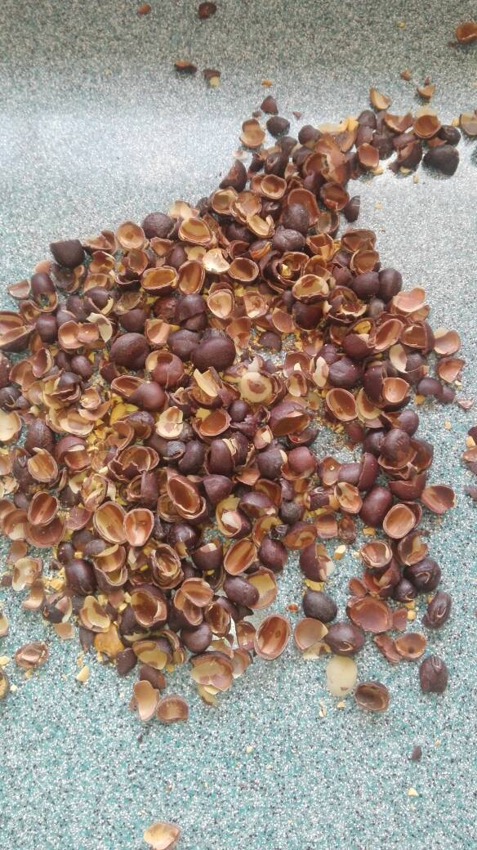

Figure 4. Marama hulls after decortication

3.4 Milling

The milling was done using a commercial blender in order to obtain flour.

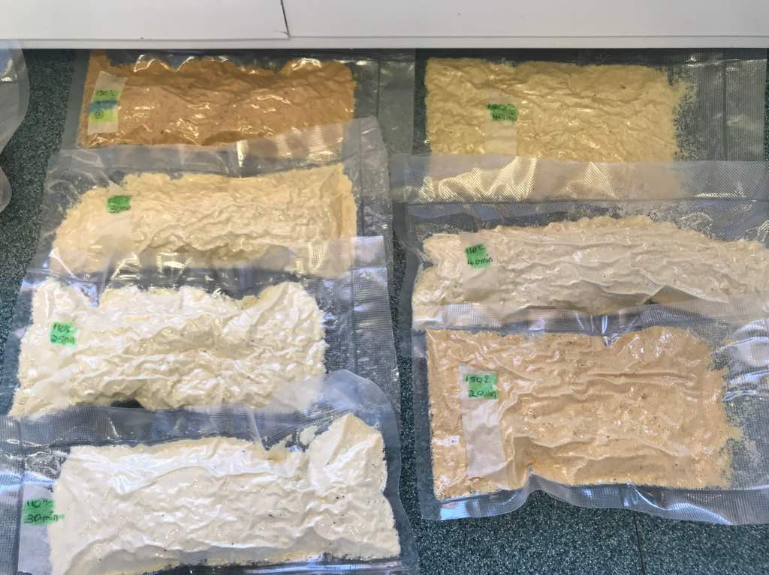

Figure 5. Marama beans milled into Marama bean flour

3.5 Determination of ash content
The ash content of Marama bean flour samples was determined by placing 5g of sample in the pre- weighed ash cups. The ash cups were then transferred to the muffle furnace for 6 hours at 550˚ C. The ash content was determined using the formula below (Kapewangolo, 2010 and St. Paul, 2000).

Ash (%) = $\frac{weight of ash}{weight of sample}$ X 100

3.6 Physicochemical properties

3.6.1 Determination of bulk density

The method described by Awolu (2017) was used to determine the bulk density of the Marama bean flour. The sample (50g) was weight into 100 ml measuring cylinder. The measuring cylinder was tapped until a constant volume was obtained. The formula below was used to calculate the bulk density:

Bulk density (g/cm³) = $\frac{weight of sample}{volume of sample after tapping}$

3.6.2 Determination of dispersibility

Dispersibility was determined using the method described by Malomo et al. (2012). The Marama bean flour sample (10g) was weighed into 100ml measuring cylinder, water was added to make up 100ml. The sample with water was stirred vigorously and allowed to stand for three hours. The volume of settled particles was recorded and the dispersibility was determined using the formula below:

Dispersibility (%) = 100- volume of settled particles

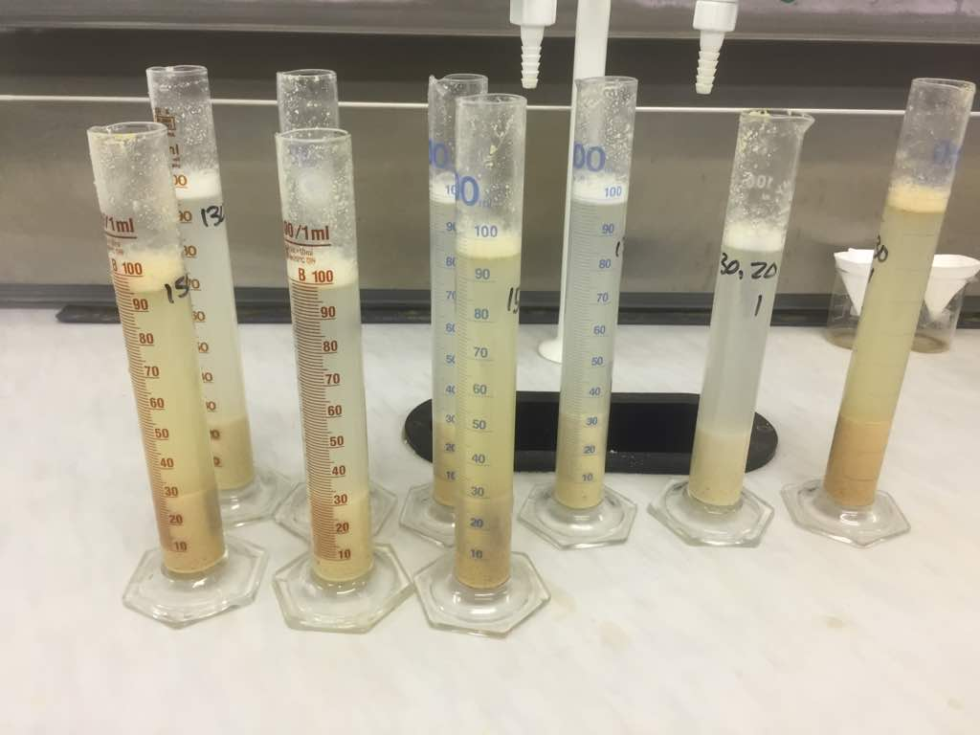

Figure 6. Dispersibility determination of Marama beans

3.6.3 Determination of oil absorption capacity

The method of Ohizua et al. (2016) and Awolu (2017) was used to determine the oil absorption capacity of Marama bean flour. One gram of sample was mixed with 10ml refined sunflower oil in a 15ml centrifuge tube and allowed to stand at room temperature for 30 minutes. The sample- oil- mixture was centrifuged at 3000rpm for 20 minutes. After centrifugation, the supernatant was poured out into 10ml graduated cylinder and the volume of free oil was recorded. The density of refined sunflower oil is 0.092 g/cm³ (Hodgman, 2003). The fomula below was used to determine the OAC:

OAC (%) = $\frac{Amount oil added-free oil}{weight of sample}$ X density of refined sunflower oil X 100

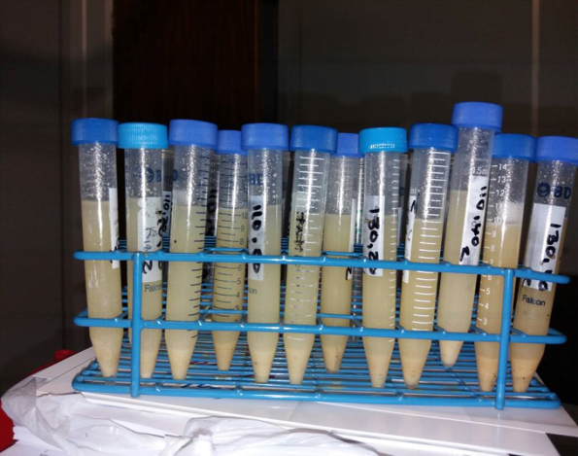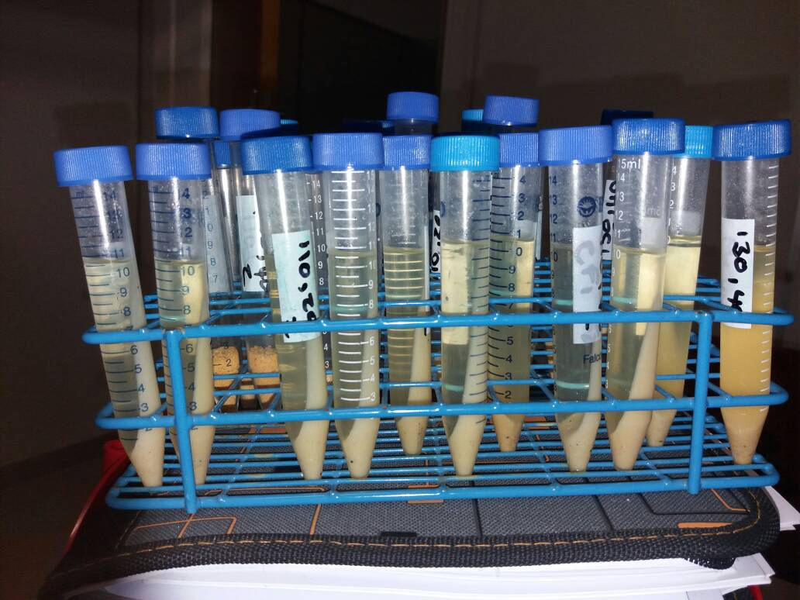

Figure 7. OAC before and after centrifugation

3.6.4 Determination of water absorption capacity

The water absorption capacity of Marama bean flour was determined using the method outlined by Awolu (2017) and Ohizua et al. (2016). About 0.5g of the sample was dissolved with 10ml of distilled water in centrifuged tubes and vortexed for 30 seconds. The dispersions were allowed to stand 30 minutes at room temperature and then centrifuged at 3000rpm for 25 minutes. After centrifugation the supernatant was filtered with whatmann No 1 filter paper and the volume was measured in a cylinder. The density of water is1 g/cm³. The WAC of Marama bean flour was determined using the formula below:

WAC (%) = $\frac{amount of water added-free water}{weight of sample}$ X density of water X 100

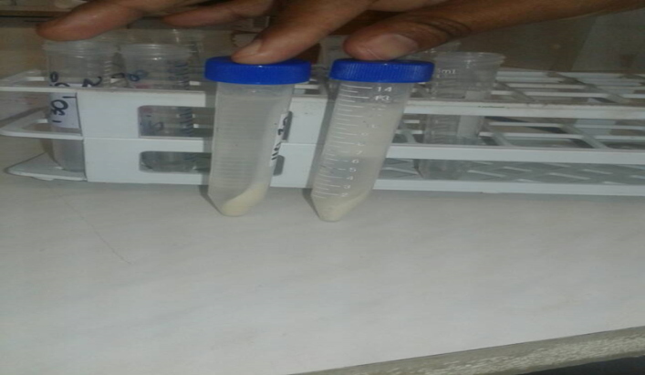
Figure 8. WAC after centrifugation

3.6.5 Determination of water solubility index

The water absorption index was determined according to the method outlined by Kumar, Sarkar and Sharma (2010). About 1 g of the Marama bean flour was weighed into 125ml conical flask. Exactly 15ml of distilled water was added and then vortexed for 5 minutes at low speed. The suspension was allowed to stand for 30 minutes, gently stirred during this period and then centrifuged at 3000rpm for 15 minutes. The supernatant was poured into a evaporating dish of a known weight. The WSI of Marama bean flour was determined using the formula below:

WSI (%) = $\frac{weight of dry solids in supernatant}{dry sample weigh}$ X 100

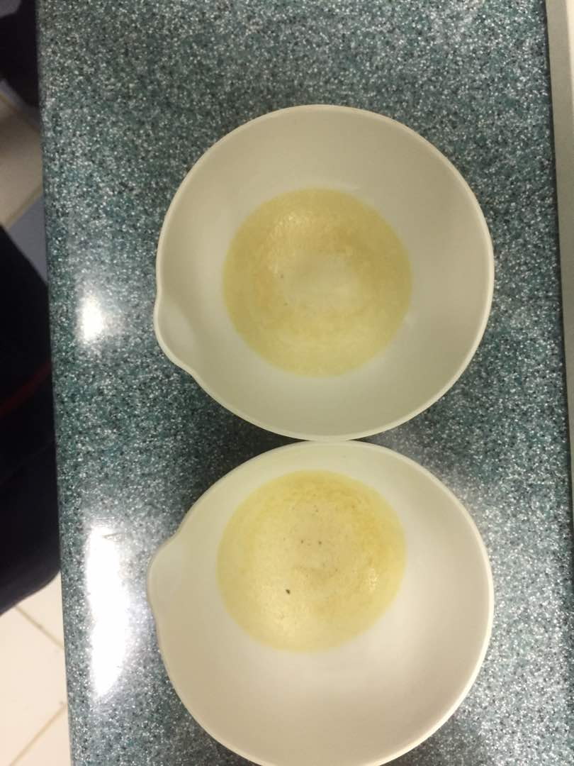

Figure 9. Supernatant dried in evaporating dishes

3.6.6 Determination of swelling index
The method outlined by Awolu (2017) was used to determine the SI of Marama bean flour. About 25g of the sample was weight in a 210ml measuring cylinder. Distilled water (150ml) was added and allowed to stand for four hours before observing the level of swelling. The formula below was used to calculate the SI:

SI (ml) = $\frac{Volume after soaking-volume before soaking}{weight of sample}$

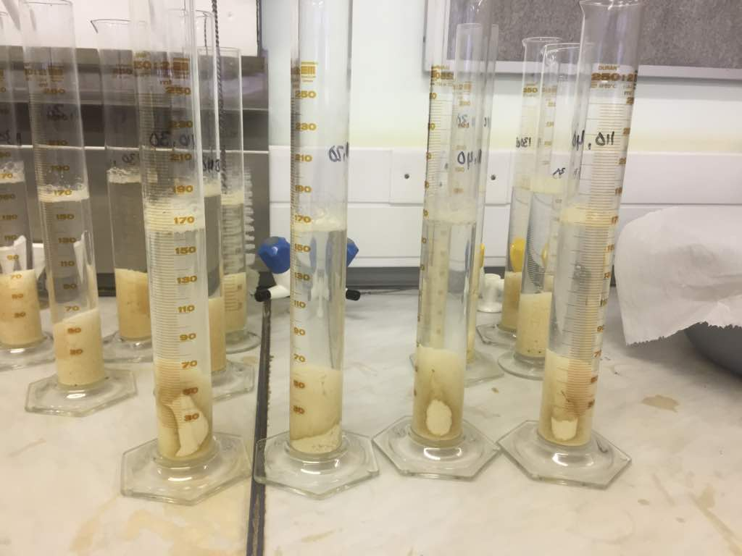

Figure 10. Swelling index determination

3.7 Data analysis

The data was analysed using the analysis of variance (ANOVA) (Young, Sanders, Drake, Osborne & Civille, 2005). The means for the different attributes were evaluated at the 5% significance level. The Microsoft excel was used to draw the graphs for the different attributes.

CHAPTER 4

RESULTS

Table 2. The mean± SD of ash content and physicochemical properties of Marama bean flour.

Ash content (%) | 3.1±0.04
Bulk density (g/cm³) | 0.7±0.03
Dispersibility (%) | 69.6±3.3
Oil absorption capacity (%) | 126.8±14.6
Swelling index (ml) | 0.3±0.05
Water absorption capacity (%) | 683.3±100.0
Water solubility index (%) | 5.9±0.6

Table 3. Roasting time and temperature that yields the highest ash content and physicochemical properties.

 | Roasting time (minutes) and temperature (˚ C)
 | 25-0 | 110-20 | 110-30 | 110-40 | 130-20 | 130-30 | 130-40 | 150-20 | 150-30 | 150-40
Ash
BD
Dispersibility
OAC
SI
WAC
WSI

4.1 Ash content

The ash content ranged between 2.80%- 3.22%. The statistical results reveal that duration of roasting has no significant (P> 0.05) effect on the ash content of the Marama bean flour. The roasting temperature also has no significant (P> 0.05) effect on the ash content of the Marama bean flour from roasted undecorticated Marama beans. The temperature and duration combination has no significant effect (P> 0.05) on the ash content of the Marama bean flour made from roasted undecorticated Marama beans. The R square= 0.262, indicate that there is 26.2% variation in the data with this model.

4.2 Bulk density (BD)

The bulk density of Marama bean flour ranged between 0.60 g/cm³- 0.71g/cm³. Statistically duration of roasting has no significant (P> 0.05) effect on the bulk density of the Marama bean flour, however the temperature of roasting has a significant (P< 0.05) effect on the bulk density of Marama bean flour obtained from roasting undecorticated Marama beans. The temperature and duration combination has no significant (P> 0.05) effect on the bulk density of roasted Marama bean flour. The variation in the data with this model is 51.7% (R square= 0.517).

4.3 Dispersibility

The dispersibility of the Marama bean flour ranged between 63%- 75%. Stististically duration of roasting has no significant (P> 0.05) effect on the dispersibility of the Marama bean flour, while the temperature of roasting has a significant (P<0.05) effect on the dispersibility of the Marama bean flour. The duration and temperature combination showed that time and temperature has a significant (P<0.05) on the dispersibility of marama bean flour. There is 87% variation in the data with this model (R= 0.870). The Post- Hoc Test (LSD) show that for the temperature, 25˚ C and 110˚ C were not significantly different from each other, but they were significantly different from 130˚ C and 150˚ C. It also show that 20 minutes and 30 minutes was not significantly different from each other but they were statistically different from 40 minutes.

4.4 Swelling index (SI)

The swelling index ranged between 0.24-0.44ml. The roasting duration statistically has no significant (P> 0.05) effect on the SI of Marama bean flour, whereas the roasting temperature has a significant (P< 0.05) effect on the Marama bean flour. Roasting duration and temperature has a significant (P< 0.05) effect on the SI of Marama bean flour. There is 81.9% variation in the data with this model. The Post- Hoc Test (LSD) show that for the temperature, 110˚ C and 130˚ C were not significantly different from each other, but they were significantly different from 25˚ C and 150˚ C. It also show that 20 minutes and 40 minutes was not significantly different from each other but they were statistically different from 30 minutes.

4.5 Oil absorption capacity (OAC)

The oil absorption capacity of Marama bean flour ranged between 92%- 138.10%. The statistical results obtained from this study show that roasting duration is has a significant (P< 0.05) effect on the OAC of the Marama bean flour. The roasting temperature also has a significant (P< 0.05) effect on the OAC of the Marama bean flour. The interaction between roasting temperature and duration also has a significant (P< 0.05) effect on the OAC of the Marama bean flour. There is a 97.9% variation in the data with this model (R square= 0.979). The Post- Hoc Test (LSD) show that for the temperature, 25˚ C and 110˚ C were not significantly different from each other, but they were significantly different from 130˚ C and 150˚ C. It also show that 20 minutes and 30 minutes was not significantly different from each other but they were statistically different from 40 minutes.

4.6 Water absorption capacity (WAC)

The WAC of Marama bean flour ranged between 600%- 800%. The statistical results obtained from this study for WAC reveal that roasting duration has no significant (P> 0.05) effect on the WAC of the Marama bean flour, whereas the roasting temperature has a significant (P< 0.05) effect on the WAC of the marama bean flour. Roasting temperature and duration has a significant (P< 0.05) effect on the Marama bean flour. There is a 46.3% variation in data with this model.

4.7 Water solubility index (WSI)

The water solubility index ranged between 5.08%- 6.86%. The roasting duration has no
significant (P> 0.05) effect on the WSI of Marama bean flour, whereas the roasting
temperature has a significant (P< 0.05) effect on the Marama bean flour. Roasting
temperature and time has a significant (P< 0.05) effect on the WSI of Marama bean flour.
There is 46.8% variation in the data with this model. The Post- Hoc Test (LSD) show that for
the temperature, 25˚ C and 150˚ C were not significantly different from each other, but they
was significantly different from 110˚ C and 130˚ C.

Chapter 5

Discussion

In this chapter, the effect of roasting duration and time will be discussed.

5.1 Ash content

The maximum ash content (3.22%) compares with literature review on the Marama beans which was found to be 3.29% (Museler and Schondfeldt, 2006), but higher than the ash content (2.9%) that was found in the study contacted by Kapewangolo (2010). Aimalo et al.(2014) it was found that the ash content of roasted Bambara groundnuts was 2.91% lower than that which was found in this study, and the author concluded in his study that the ash content was not significantly affected by roasting. This conclusion is in agreement with what was found in this study as the ash content was significantly affected by roasting. According to Zita (2013) depending on the variety, soil conditions, climate and other factors, the ash content will vary from flour to flour. According to Holse, Husted and Hansen (2010) the Marama beans from South Africa have a higher ash content that those from Botswana and Namibia, thus the area of harvest affect the ash content of Marama beans.

5.2 Physicochemical properties

5.2.1 Bulk density (BD)
Ayodele and Ade- Omowaye (2015) found that the bulk density of different legume flours ranged between 0.791-0.869g/cm³, which is comparable to that which was found in this study (0.60- 0.71g/cm³), although the bulk density in this study is lower than that found in literature. As the roasting time increases, the bulk density decreases according to Chung (2012). This may be the reason for the lower BD found in this study. The bulk density is influenced by the particle size and the density of the flour. It is also influenced by the structure of the starch polymers and the loose structure of the starch polymer which could result in low bulk density (Malomo et al., 2012).

5.2.2 Dispesibility
Molomo (2012) showed that the dispersibility of soy flour is 56.50%. The dispersibility of soy flour is lower than that for the Marama bean flour found in this study (63-75%). According to Ayodele and Ade-Omowaye (2015) this could be due to the lower water absorption capacity (WAC) of the soy flour (130%). The WAC of Marama bean flour found in this study is in the range of 600-800% and this indicates that the Marama bean flour can reconstitute water better than the soy flour. This further contributes to the higher dispersibility of the Marama bean flour. According to Eke, Beleya and Onyyenorah (2014) roasting prior to flour production results in higher dispersibility. The dispersibility of Marama beans that were not roasted (controls) had the highest dispersibility (73.30%) followed by that roasted at 110˚C for 20 minutes (72%).

5.2.3 Swelling index (SI)
According to (Appiah, Asibuo and Kumah, 2011) the SI of three different cowpea varieties was as follow: Nhyira 0.025ml, Tona 0.025ml and Adom 0.028ml, which is lower than that found in this study (0.24- 0.44ml). The higher SI found in this study could be due to the presence of water, the species of starch, extent of starch damage due to thermal processing (Ojukwa, Olawuni and Iwouno , 2012).

5.2.4 Oil absorption capacity (OAC)
Awolu (2017) showed that the composite flour with kidney beans ranged from 124-188% which is higher than the values found in this study as it was composite flour. Jideani, Van Wyk and Cruywagen (2009) showed that the Marama beans which were roasted at 160˚ C for 15 minutes had the OAC of 27.3% for dark brown Marama variety and 27.6% for light brown Marama variety. The higher OAC for Marama beans flour (92-138%) found in this study may be due to the longer roasting durations. This is supported by Oulai et al. (2014) whereby he indicates that the heat treatments denature the proteins which unmask the nonpolar residues from protein molecular and this in turn results in higher OAC.

5.2.5 Water absorption capacity (WAC)
According to Ayodele and Ade-Omuwaye, (2015) the WAC of selected legumes in Nigeria were as follow: Cassia hirsutta 266.4%, Vigna racemose 216.3%, soy flour 130% and Pigeon pea 130%. The WAC found in the literature is lower than that found in this study. The presence of fat, though in small quantity may be responsible for the moderate quantity of the WAC for each legume (Ayodele and Ade-Omuwaye, 2015). Khan and Saini showed that the higher WAC may be due to the existing difference in the conformational characteristics of proteins in different legumes. That could be the reason why the Marama bean flour has a very high WAC than the other legumes in the literature. According to Eke, Beleya and Onyenora (2014) the denaturation of proteins in flour due to heat processing bind more water and hence could lead to flour with higher water absorption capacity. According to Oulai (2014) the ability of food to absorb water may be sometimes attributed to its proteins content. Proteins in flour that have been denatured due to heat processing bind more water.

5.2.6 Water solubility index (WSI)
Nikolaos, Oikonomou and Krokida (2011) showed that the WSI of soy flour is 4.06- 5.03% which is lower than that which was found in this study. The WSI is affected by the particle size of the flour. The finer the particle size of the flour is, the higher the WSI. This may be the reason for the higher WSI found in this study because the flour was sieved.

CHAPTER 6

CONCLUSION AND RECCOMMENDATIONS

6.1 Conclusion

Roasting Marama beans at 110˚ C for 20 minutes increased the ash content (3.14%) and the dispersibility (72%), while roasting at 110˚ C for 30 minutes increased the OAC (138%). Roasting at 130˚C for 30 minutes increased the WSI (6.13%). Roasting Marama beans at 150˚ C for 20 minutes increased the SI (0.47ml), while roasting at 150˚ C for 30 minutes increased both the WAC (800%) and the BD (0.71g/cm³). According to literature review, high ash content, BD, dispersibility, OAC, SI, WAC and WSI are all important properties for making a paste. Roasting at lower temperatures resulted in higher ash content, OAC and dispersibility, while roasting at higher temperatures showed higher Si, BD and WAC. Roasting Marama beans at the temperature in between 110˚C and 150˚ C may be suitable to formulate RUTF. Therefore roasting Marama beans at 130˚ C for either at 20minutes or 30 minutes may be suitable to formulate RUTF paste.

6.2 Recommendations
- Further studies can be conducted to evaluate the organoleptic and important nutritional properties of Marama bean to formulate RUTF.
- Formulation cost of RUTF from Marama bean flour.
- Comparison of the RUTF from Marama bean flour with the commercially available RUTF.
- The microbial food safety evaluation of RUTF from Marama bean flour.

References

Awolu, O. O. (2017). Optimization of functional characteristics, pasting and rheological properties of pearl millet- based composite flours. Federal University of Technology, Nigeria.

Ayodele, O. M., Ade-Omowaye, B. I. O. (2015). Some Functional and Physical
Properties of Selected Underutilised Hard-To-Cook Legumes in Nigeria. American Journal of Food Science and Nutrition 2(5): 73-84.

Bower, N., Hertel, K.,Oh, J.,& Storey, R. (1988). Nutritional evaluation of marama bean (Tylosema esculentum): Analysis of the Seed. New York: Colorado Springs

Bechman, R. A. (2008). Formulation and development of peanut- based ready-to-used therapeutic foods for malnourished pregnant women in Mali. Published research report, University of Georgia. Retrieved March 08, 2017 from https://www.ncbi.nlm.nih.gov/pmc/articles/PMC4376405/

Chimwamurombe, P. (2011). Indigenous plant products in Namibia. Retrieved April 05, 2017 from http://www.nbri.org.na/sections/economic-botany/INP/sectors/Marama-bean

Chingwaru, W.,& Majinda, R. T.,Yeboah, S. O., Jackson, J. C., Kapewangolo, T. P., Kandawa-Schulz, M., & Cencic, A. (2011). Tylosema esculentum (Marama) Tuber and Bean Extracts Are Strong Antiviral Agents against Rotavirus Infection. Retrieved May 16, 2017 from https://www.hindawi.com/journals/ecam/2011/284795/

Black, R.E. (2008). Maternal and child undernutrition: global and regional exposures and health consequences. Retrieved January 09, 2017 from https://www.ncbi.nlm.nih.gov/pubmed/18207566

Briend, A., & Collins, S. (2010). Therapeutic Nutrition for Children with Severe Acute Malnutrition: Summary of African Experience. UK: Oxford

Dakora, F. D. (2013): Biogeographic Distribution, Nodulation and Nutritional Attributes of Underutilized Indigenous African Legumes. Retrieved July 03, 2017 from https://en.wikipedia.org/wiki/Tylosema_esculentum#cite_note-3

Echo plant information sheet. (2016). Marama beans. Retrieved February 22, 2017 from
https://www.echocommunity.org/pt/resources/9e6b7a74-93c9-428e-928a-00b6dcb65d63.pdf

Eke- Ejiofor, J., Beleya, E. A., & Onyenorah, N. I. (2014). The effect of processing methods on the functional and compositional properties of jackfruit seed flour. International Journal of Nutrition and Food Sciences 3(3): 166-173

Holse, M., Hansen, A. S., & Husted, S. (2010). Chemical composition of marama bean (Tylosema esculentum): A wild African bean with unexploited potential. University of Copenhagen. Department of Food Science. Retrieved February 17, 2017 from https://www.researchgate.net/publication/223874282_Chemical_composition_of_marama_bean_Tylosema_esculentum-A_wild_African_bean_with_unexploited_potential

Holse, M., Hansen, A.S.,& Skove, T. (2012). Oxidative Storage Stability of Roasted Marama Beans (Tylosema Esculentum). Retrieved August 18, 2017 from https://www.researchgate.net/publication/251629321_Oxidative_Storage_Stability_of_Roasted_Marama_Beans_Tylosema_Esculentum

Jideani, V. A.,Van Wyk, J., & Cruywagen, M. H. (2009). Physical properties of Tylosemia esculentum and the effect of roasting on the functional properties of its flour. African Journal of Agricultural Research Vol. 4 (11), pp. 1208-1219

Kapewangolo, T. P. (2010). Biochemical characteristics of Marama bean (Tylosema esculentum): Quality evaluation and health potentials in functional cell models. Published master’s thesis, University of Namibia. Retrieved from http://wwwisis.unam.na/theses/kapewangolo2010.pdf

Kayitesi, E., deKock, H. L., Minnaar, A.,& Duodu, K. G. (2012). Nutritional quality and antioxidant activity of marama- sorghum composite flours and porridges. University of Pretoria. Food Chemistry 131 (2012) ,837-842

Khan, A.,& Saini, C.S. (2016). Effect of roasting on physicochemical and
functional properties of flaxseed flour. Retrieved April 20, 2017 from https://www.cogentoa.com/article/10.1080/23311916.2016.1145566

Kumar, N.,Sarkar, B.C.,& Sharma, H.K. (2010). Development and characterization of extruded product of carrot pomace, rice flour and pulse powder. African Journal of Food Science Vol. 4(11), pp. 703 – 717

Maruatona, G. N., Duodu, K. G. & Minnaar, A., (2010). Physicochemical, nutritional and functional properties of marama bean flour. Retrieved June 01, 2017 from https://en.wikipedia.org/wiki/Tylosema_esculentum#cite_note-book-7

Maruatona, G. N. (2008). Physico- chemical, nutritional and functional properties of defatted marama bean flour. Published master’s thesis, University of Pretoria. Retrieved March 07, 2017 from https://repository.up.ac.za/bitstream/handle/2263/25452/dissertation.pdf?sequence=1

Manary, J. M. (2005). Local production and provision of ready-to-use therapeutic
food for the treatment of severe childhood malnutrition. Washington University School of Medicine, St. Louis, MO, USA.

Marshall, M. R. (2010). Ash Analysis. Retrieved April 22, 2017 from https://link.springer.com/chapter/10.1007/978-1-4419-1478-1_7

Malomo, O., Ogunmoyela, O. A. B., Adekoyeni, O. O., Jimoh, O., Oluwajoba, S.O .,& Sobanwa M. O. (2012). Rheological and Functional Properties of Soy-Poundo Yam Flour. International Journal of Food Science and Nutrition Engineering. Nigeria

Museler, D. L., & Schonfeldt, H. C. (2006). The nutrient content of the marama bean (Tylosema esculentum), an underutilised legume from Southern Africa. Published master’s thesis, University of Namibia. Retrieved April 20, 2017 from http://www.the-eis.com/data/literature/Agricola_2006_No16_02_Museler_Schonfeldt.pdf

Museler, D. L. (2005). Evaluation of quality characteristics of the marama bean (Tylosema esculentum), an underutilised grain and tuber producing legume in Southern Africa. Published masters research report, University of Namibia.

Müller, O.,& Krawinkel, M. (2005). Malnutrition and health in developing countries. Retrieved August 18, 2017 from https://www.ncbi.nlm.nih.gov/pubmed/16076825

Ohizua, E. R., Adeola, A. A., Idowu, M.A., Sobukola, O. P., Afolabi, T. A., Ishola, R. O., Ayansina, S. M., Oyekale, T. O.,& Falomo, A. (2016). Nutrient composition, functional, and pasting properties of unripe cooking banana, pigeon pea, and sweet potato flour blends. Retrieved July 12, 2017 from https://www.researchgate.net/publication/312357652_Nutrient_composition_functional_and_pasting_properties_of_unripe_cooking_banana_pigeon_pea_and_sweetpotato_flour_blends

Offia- Olua, I. B. (2014). Chemical, Functional and Pasting Properties of Wheat (Triticumspp)- Walnut (Juglansregia) Flour. Michael Okpara University of Agriculture, Nigeria

Oulai, S, F., Ahi, I. P., Kouassi-Koffie, J. D., Gonnety, J. T., Faulet, B. M.,Dje, K. M.,&Koume, L. P. (2014). Treatments Effects on Functional Properties of Breadfruit (Artocarpus altilis) Pulp Flour harvested in Côte d’Ivoire. Retrieved June 12, 2017 http://www.ijrbp.com/file/2014%20Volume%202,%20issue%204/IJRB-2014-2-4-1-12.pdf

Oluwole, O., Akinwal ,T., Adesioye , T., Odediran, O., Anuoluwatelemi, J., Ibidapo, O ., Owolabi, F .,.. Kosoko, S. (2016). Some functional properties of flours from commonly consumed selected Nigerian Food Crops. International Research Journal of Agricultural and Food Sciences, Vol. 1 Issue 5, pp: (92-98)
Ojukwu, M., Olawuni, I.,& Iwouno, J.O. (2012). The Proximate Composition and Functional Properties of Full-Fat Flour, and Protein Isolate of Lima Bean (Phaseolus Lunatus). Retrieved May 15, 2017 from https://www.omicsonline.org/scientific-reports/2155-9600-SR-349.pdf

Oikonomou, N, A.,& Krokida, M.K. (2011). Literature data compilation of WAI and WSI of extrudate food products. Retrieved April 22, 2017 from https://scholar.google.gr/citations?user=wDUxb-cAAAAJ&hl=en

St. Paul, M. N. (2000). Wheat quality testing methods. Retrieved April 22, 2017 from https://nebraskawheat.com/wp-content/uploads/2014/01/WheatFlourTestingMethods.pdf

Wagh, V. D.,& Deore, B. R. (2015). Ready to Use Therapeutic Food (RUTF): An
Overview. Advances in Life Sciences and Health. Maharashtra, India

Walton, E., & Allen, S. (2011). Malnutrition in developing countries. Retrieved May 15, 2017 from http://www.paediatricsandchildhealthjournal.co.uk/article/S1751-7222(11)00092-8/abstract

Zita, K. (2013). Ash Content of American and European Flour Types. Retrieved May 29, 2017 from http://www.sourdoughlibrary.org/flour-ash-content/

Appendices

Appendix 1.

ANOVA table for ash content and the physicochemical properties of Marama bean flour.

Ash content

Tests of Between-Subjects Effects
Dependent Variable: Ashcontent
Source | Type III Sum of Squares | df | Mean Square | F | Sig.
Corrected Model | .011ª | 9 | .001 | 1.185 | .340
Intercept | 347.699 | 1 | 347.699 | 326733.710 | .000
Time | .004 | 2 | .002 | 1.772 | .187
Temperature | .007 | 2 | .003 | 3.143 | .058
Time * Temperature | .001 | 4 | .000 | .206 | .933
Error | .032 | 30 | .001
Total | 391.106 | 40
Corrected Total | .043 | 39
a. R Squared = .262 (Adjusted R Squared = .041)

Bulk density

Tests of Between-Subjects Effects
Dependent Variable: Bulkdensity
Source | Type III Sum of Squares | df | Mean Square | F | Sig.
Corrected Model | .021ª | 9 | .002 | 3.575 | .004
Intercept | 15.525 | 1 | 15.525 | 23316.711 | .000
Time | .002 | 2 | .001 | 1.381 | .267
Temperature | .011 | 2 | .006 | 8.315 | .001
Time * Temperature | .007 | 4 | .002 | 2.670 | .051
Error | .020 | 30 | .001
Total | 17.611 | 40
Corrected Total | .041 | 39
a. R Squared = .517 (Adjusted R Squared = .373)

Dispersibility

Tests of Between-Subjects Effects
Dependent Variable: Dispersibility
Source | Type III Sum of Squares | df | Mean Square | F | Sig.
Corrected Model | 383.056ª | 9 | 42.562 | 22.328 | .000
Intercept | 176216.839 | 1 | 176216.839 | 92441.620 | .000
Time | 22.222 | 2 | 11.111 | 5.829 | .007
Temperature | 287.389 | 2 | 143.694 | 75.381 | .000
Time * Temperature | 22.444 | 4 | 5.611 | 2.944 | .036
Error | 57.188 | 30 | 1.906
Total | 196370.250 | 40
Corrected Total | 440.244 | 39
a. R Squared = .870 (Adjusted R Squared = .831)

Swelling index

Tests of Between-Subjects Effects
Dependent Variable: Swellingindex
Source | Type III Sum of Squares | df | Mean Square | F | Sig.
Corrected Model | .095ª | 9 | .011 | 15.036 | .000
Intercept | 3.832 | 1 | 3.832 | 5461.528 | .000
Time | .008 | 2 | .004 | 6.037 | .006
Temperature | .017 | 2 | .008 | 11.904 | .000
Time * Temperature | .025 | 4 | .006 | 9.024 | .000
Error | .021 | 30 | .001
Total | 4.740 | 40
Corrected Total | .116 | 39
a. R Squared = .819 (Adjusted R Squared = .764)

Oil absorption capacity

Tests of Between-Subjects Effects
Dependent Variable: Oilabsorption
Source | Type III Sum of Squares | df | Mean Square | F | Sig.
Corrected Model | 7469.957ª | 9 | 829.995 | 157.840 | .000
Intercept | 592639.920 | 1 | 592639.920 | 112702.522 | .000
Time | 1325.704 | 2 | 662.852 | 126.055 | .000
Temperature | 4648.256 | 2 | 2324.128 | 441.980 | .000
Time * Temperature | 1044.301 | 4 | 261.075 | 49.649 | .000
Error | 157.753 | 30 | 5.258
Total | 661900.162 | 40
Corrected Total | 7627.710 | 39
a. R Squared = .979 (Adjusted R Squared = .973)

Water absorption capacity

Tests of Between-Subjects Effects
Dependent Variable: Waterabsorptipncapacity
Source | Type III Sum of Squares | df | Mean Square | F | Sig.
Corrected Model | 181000.000ª | 9 | 20111.111 | 2.873 | .014
Intercept | 16776076.923 | 1 | 16776076.923 | 2396.582 | .000
Time | 6666.667 | 2 | 3333.333 | .476 | .626
Temperature | 46666.667 | 2 | 23333.333 | 3.333 | .049
Time * Temperature | 126666.667 | 4 | 31666.667 | 4.524 | .006
Error | 210000.000 | 30 | 7000.000
Total | 19160000.000 | 40
Corrected Total | 391000.000 | 39
a. R Squared = .463 (Adjusted R Squared = .302)

Water solubility index

Tests of Between-Subjects Effects
Dependent Variable: Watersolubilityindex
Source | Type III Sum of Squares | df | Mean Square | F | Sig.
Corrected Model | 5.744ª | 9 | .638 | 2.936 | .013
Intercept | 1182.936 | 1 | 1182.936 | 5441.161 | .000
Time | .240 | 2 | .120 | .551 | .582
Temperature | 2.068 | 2 | 1.034 | 4.755 | .016
Time * Temperature | 2.514 | 4 | .629 | 2.891 | .039
Error | 6.522 | 30 | .217
Total | 1367.395 | 40
Corrected Total | 12.266 | 39
a. R Squared = .468 (Adjusted R Squared = .309)

Appendix 2.

Post- hoc Test (LSD) tables for the selected data.

Oil absorption capacity (temperature)

Multiple Comparisons
Dependent Variable: Oilabsorption
LSD
(I) Temperature | (J) Temperature | Mean Difference (I-J) | Std. Error | Sig. | 95% Confidence Interval
 |  |  |  |  | Lower Bound | Upper Bound
25.00 | 110.00 | 1.0117 | 1.32394 | .451 | -1.6922 | 3.7155
 | 130.00 | 5.5350* | 1.32394 | .000 | 2.8312 | 8.2388
 | 150.00 | 27.0575* | 1.32394 | .000 | 24.3537 | 29.7613
110.00 | 25.00 | -1.0117 | 1.32394 | .451 | -3.7155 | 1.6922
 | 130.00 | 4.5233* | .93617 | .000 | 2.6114 | 6.4352
 | 150.00 | 26.0458* | .93617 | .000 | 24.1339 | 27.9577
130.00 | 25.00 | -5.5350* | 1.32394 | .000 | -8.2388 | -2.8312
 | 110.00 | -4.5233* | .93617 | .000 | -6.4352 | -2.6114
 | 150.00 | 21.5225* | .93617 | .000 | 19.6106 | 23.4344
150.00 | 25.00 | -27.0575* | 1.32394 | .000 | -29.7613 | -24.3537
 | 110.00 | -26.0458* | .93617 | .000 | -27.9577 | -24.1339
 | 130.00 | -21.5225* | .93617 | .000 | -23.4344 | -19.6106
Based on observed means.
The error term is Mean Square(Error) = 5.258.
*. The mean difference is significant at the 0.05 level.
Oil absorption capacity (time)

Multiple Comparisons
Dependent Variable: Oilabsorption
LSD
(I) Time | (J) Time | Mean Difference (I-J) | Std. Error | Sig. | 95% Confidence Interval
 |  |  |  |  | Lower Bound | Upper Bound
.00 | 20.00 | 6.9292* | 1.32394 | .000 | 4.2253 | 9.6330
 | 30.00 | 6.8917* | 1.32394 | .000 | 4.1878 | 9.5955
 | 40.00 | 19.7833* | 1.32394 | .000 | 17.0795 | 22.4872
20.00 | .00 | -6.9292* | 1.32394 | .000 | -9.6330 | -4.2253
 | 30.00 | -.0375 | .93617 | .968 | -1.9494 | 1.8744
 | 40.00 | 12.8542* | .93617 | .000 | 10.9423 | 14.7661
30.00 | .00 | -6.8917* | 1.32394 | .000 | -9.5955 | -4.1878
 | 20.00 | .0375 | .93617 | .968 | -1.8744 | 1.9494
 | 40.00 | 12.8917* | .93617 | .000 | 10.9798 | 14.8036
40.00 | .00 | -19.7833* | 1.32394 | .000 | -22.4872 | -17.0795
 | 20.00 | -12.8542* | .93617 | .000 | -14.7661 | -10.9423
 | 30.00 | -12.8917* | .93617 | .000 | -14.8036 | -10.9798
Based on observed means.
The error term is Mean Square(Error) = 5.258.
*. The mean difference is significant at the 0.05 level.

Dispersibility (temperature)

Multiple Comparisons
Dependent Variable: Dispersibility
LSD
(I) Temperature | (J) Temperature | Mean Difference (I-J) | Std. Error | Sig. | 95% Confidence Interval
 |  |  |  |  | Lower Bound | Upper Bound
25.00 | 110.00 | .3750 | .79713 | .641 | -1.2530 | 2.0030
 | 130.00 | 3.6250* | .79713 | .000 | 1.9970 | 5.2530
 | 150.00 | 7.2917* | .79713 | .000 | 5.6637 | 8.9196
110.00 | 25.00 | -.3750 | .79713 | .641 | -2.0030 | 1.2530
 | 130.00 | 3.2500* | .56366 | .000 | 2.0989 | 4.4011
 | 150.00 | 6.9167* | .56366 | .000 | 5.7655 | 8.0678
130.00 | 25.00 | -3.6250* | .79713 | .000 | -5.2530 | -1.9970
 | 110.00 | -3.2500* | .56366 | .000 | -4.4011 | -2.0989
 | 150.00 | 3.6667* | .56366 | .000 | 2.5155 | 4.8178
150.00 | 25.00 | -7.2917* | .79713 | .000 | -8.9196 | -5.6637
 | 110.00 | -6.9167* | .56366 | .000 | -8.0678 | -5.7655
 | 130.00 | -3.6667* | .56366 | .000 | -4.8178 | -2.5155
Based on observed means.
The error term is Mean Square(Error) = 1.906.
*. The mean difference is significant at the 0.05 level.

Dispersibility (time)

Multiple Comparisons
Dependent Variable: Dispersibility
LSD
(I) Time | (J) Time | Mean Difference (I-J) | Std. Error | Sig. | 95% Confidence Interval
 |  |  |  |  | Lower Bound | Upper Bound
.00 | 20.00 | 3.2083* | .79713 | .000 | 1.5804 | 4.8363
 | 30.00 | 3.2083* | .79713 | .000 | 1.5804 | 4.8363
 | 40.00 | 4.8750* | .79713 | .000 | 3.2470 | 6.5030
20.00 | .00 | -3.2083* | .79713 | .000 | -4.8363 | -1.5804
 | 30.00 | .0000 | .56366 | 1.000 | -1.1511 | 1.1511
 | 40.00 | 1.6667* | .56366 | .006 | .5155 | 2.8178
30.00 | .00 | -3.2083* | .79713 | .000 | -4.8363 | -1.5804
 | 20.00 | .0000 | .56366 | 1.000 | -1.1511 | 1.1511
 | 40.00 | 1.6667* | .56366 | .006 | .5155 | 2.8178
40.00 | .00 | -4.8750* | .79713 | .000 | -6.5030 | -3.2470
 | 20.00 | -1.6667* | .56366 | .006 | -2.8178 | -.5155
 | 30.00 | -1.6667* | .56366 | .006 | -2.8178 | -.5155
Based on observed means.
The error term is Mean Square(Error) = 1.906.
*. The mean difference is significant at the 0.05 level.

Swelling index (temperature)
Multiple Comparisons
Dependent Variable: Swellingindex
LSD
(I) Temperature | (J) Temperature | Mean Difference (I-J) | Std. Error | Sig. | 95% Confidence Interval
 |  |  |  |  | Lower Bound | Upper Bound
25.00 | 110.00 | -.1292* | .01529 | .000 | -.1604 | -.0979
 | 130.00 | -.1233* | .01529 | .000 | -.1546 | -.0921
 | 150.00 | -.0808* | .01529 | .000 | -.1121 | -.0496
110.00 | 25.00 | .1292* | .01529 | .000 | .0979 | .1604
 | 130.00 | .0058 | .01081 | .594 | -.0163 | .0279
 | 150.00 | .0483* | .01081 | .000 | .0262 | .0704
130.00 | 25.00 | .1233* | .01529 | .000 | .0921 | .1546
 | 110.00 | -.0058 | .01081 | .594 | -.0279 | .0163
 | 150.00 | .0425* | .01081 | .000 | .0204 | .0646
150.00 | 25.00 | .0808* | .01529 | .000 | .0496 | .1121
 | 110.00 | -.0483* | .01081 | .000 | -.0704 | -.0262
 | 130.00 | -.0425* | .01081 | .000 | -.0646 | -.0204
Based on observed means.
The error term is Mean Square(Error) = .001.
*. The mean difference is significant at the 0.05 level.

Swelling index (time)

Multiple Comparisons
Dependent Variable: Swellingindex
LSD
(I) Time | (J) Time | Mean Difference (I-J) | Std. Error | Sig. | 95% Confidence Interval
 |  |  |  |  | Lower Bound | Upper Bound
.00 | 20.00 | -.1125* | .01529 | .000 | -.1437 | -.0813
 | 30.00 | -.1292* | .01529 | .000 | -.1604 | -.0979
 | 40.00 | -.0917* | .01529 | .000 | -.1229 | -.0604
20.00 | .00 | .1125* | .01529 | .000 | .0813 | .1437
 | 30.00 | -.0167 | .01081 | .134 | -.0388 | .0054
 | 40.00 | .0208 | .01081 | .064 | -.0013 | .0429
30.00 | .00 | .1292* | .01529 | .000 | .0979 | .1604
 | 20.00 | .0167 | .01081 | .134 | -.0054 | .0388
 | 40.00 | .0375* | .01081 | .002 | .0154 | .0596
40.00 | .00 | .0917* | .01529 | .000 | .0604 | .1229
 | 20.00 | -.0208 | .01081 | .064 | -.0429 | .0013
 | 30.00 | -.0375* | .01081 | .002 | -.0596 | -.0154
Based on observed means.
The error term is Mean Square(Error) = .001.
*. The mean difference is significant at the 0.05 level.

