Fortification Potential of Mahangu at the Level of Service and Small Scale Commercial Millers

Draft Report Submitted to NAFIN
Fortification Working Group

J. Chigariro & M. Mallet, CRIAA SA-DC Consultants, 30 March 2015

Introduction
The Food Fortification Working Group (FFWG) of the Namibia Alliance for Improved Nutrition (NAFIN) convened by the Namibian Agronomic Board (NAB), is purposed to identify strategies to improve and secure the micronutrient status of all Namibians, through fortification activities. To complement existing fortification activities, the Food Fortification Working Group engaged the consultant CRIAA SA-DC to investigate the feasibility of fortifying mahangu at the service and small mill levels in Namibia.
This consultancy is aimed at assisting the Food Fortification Working Group in the decision making process to understand the process of making mahangu a viable vehicle for fortification. It is anticipated that the fortification will further improve the micronutrient quality of this cereal consumed by the Namibian public. In Namibia, it is estimated that less than 10% of mahangu produced in the grain producing areas reaches commercial milling processes. About 70% is assumed to be milled by service millers while not more than 20% is still crushed traditionally at the homestead (by means of a wooden pestle and mortar).

Background
Stunting among children under five is of public health significance in Namibia, with just under one third of children affected by the effects of long term under-nutrition. Under-nutrition also affects 15% mothers and women of child bearing age, which has significant bearing on the health and nutritional status of future generations, as small women tend to give birth to small children. Under-nutrition does not only manifest through low weight for age or weight for height, there is a far more dangerous side to malnutrition, which is a form of hidden hunger which arises from an inadequate or a lack of micronutrients in the diet. Micronutrients, though required in minute amounts in the diet, when deficient, undermine normal growth and development of processes fundamental to life, such as brain development, reproductive viability, birth outcomes and immune integrity. Under nutrition and its effects not only have negative effects on the affected individual, but has consequences of future psychosocial, intellectual and ultimately economic performance and productivity. As such under nutrition, affects individuals and ultimately the nation, as a result malnutrition is greater than a health issue it is at the heart of a nation’s economic sustainability.
Pearl millet, more commonly referred to as mahangu in Namibia is one of the three main staples of the country in Namibia. At present, the two main milling companies enrich maize and wheat flour according to South African guidelines, and there are plans to adapt the legislation to local conditions under the leadership of the Food Fortification Working Group of NAFIN. The Food Fortification Working Group is a technical working group endorsed by NAFIN to plan, devise and advise on strategies on fortification of cereal staples towards the improvement of the micronutrient status of all Namibians. However, mahangu is not commercially milled on a broad scale and where it is commercially milled, it is not enriched with micro-nutrients.

Terms of Reference
A situation analysis should be done of the impact any change in the price of fortifying services that will follow the institution of fortification at milling points and what that will have on the uptake of the service and the communities’ awareness of the benefit of fortification.
The consultant was tasked to carry out the following:
- To get a broad overview regarding mahangu service millers in Namibia (estimated to be more than 1,000).
- By means of well-advertised decentralized meetings (focus group meetings) with such mahangu service millers, explore socially, technically and financially acceptable methods of food fortification (micro-nutrients) at the point of service millers including small scale commercial millers.
- Consider possible initial and/or ongoing support to the millers for the mahangu fortification.
- As far as possible build consensus on the best way forward of the above and document.
- Specifically explore the training needs of the service millers and communities respectively to make a success of the proposed intervention.
- Include issues regarding storage of the cocktail.
- Recommend whether such future fortification would have to be compulsory or could even function efficiently on a voluntary basis. (the NAB already has the following information: (a) availability of cocktail; (b) legal choices to make it compulsory, if recommended)
- Include proposed systems or methods of monitoring that service millers are really doing what they have agreed to do.
- An assessment of the current pricing structures and the acceptability or feasibility of an increase in service charges following the inclusion of the fortification equipment and micronutrient premixes.
- Prepare a donor-ready project proposal on the implementation of the scheme and estimate its costs. This would be done as phase 2 of the consultancy, depending on the outcome the final workshop at the end of the field consultations.

This draft report is divided into two sections.
The first section deals with findings from the field work through consultations with millers and stakeholders and direct observations made by the consultant during the field visits in the regions, and reckons the conclusions attained from the regional Focus Group Meetings.
The second section of the report examines the feasibility of mahangu fortification under different scenarios presented as possible way forward.

SECTION 1 – FIELD WORK AND CONSULTATIONS
Approach and Method
To fulfil the terms of reference for the NAFIN consultancy on assessing the potential of mahangu fortification at small scale commercial and service miller levels, consultative meetings and visits were carried out between 17 October 2014 and 6 March 2015 in Windhoek and the northern regions of Namibia. Work in the regions focused on visiting millers to discuss and profile the milling facilities, consulting the relevant stakeholders and holding focus group meetings in each of the seven regions.
The study employed semi-structured interviews and a checklist was administered on groups of mill owners (Appendix 1). Preparatory meetings were held in October and November 2014 with NAB and Synergos, and with the NAFIN working group. The purpose of the meetings was to gain an in-depth understanding of the TORs for the consultancy. The meetings focused on methods that were employed during the consultations to facilitate collection of information on millers in the targeted regions. An insight into the fortification costs, equipment and general procedures were obtained from literature and Namib Mills. Interviews with the Chairperson and the vice Chairperson of the Namibia Mahangu Processing Association (NMPA) were also held in Windhoek before consultations in the regions. A meeting with NMPA members scheduled for November 2014 in Tsumeb could not take place since the dates were close to the national elections, and the meeting was indefinitely postponed. All the preparations for the field work took place in Windhoek. An introduction letter of the consultant was obtained from NAFIN.

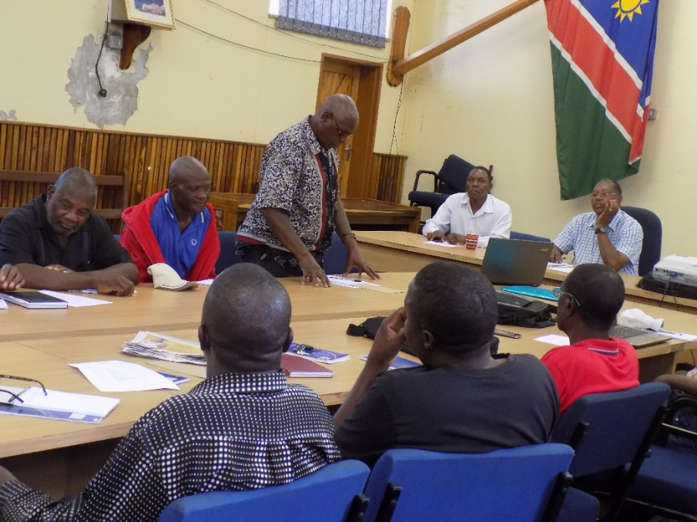
Picture 1: Focus Group Meeting in Rundu, Kavango West Region chaired by the Councillor of Rundu Urban Constituency

In each of the regions, Governors were consulted on the prevalence of malnutrition among the child under the age of 5 years and the possibility of mahangu fortification. Permission to conduct miller visits and Focus Group Meetings (FGM) was sought the from the Governors’ offices. The Governors assisted in selecting suitable constituencies that would represent their regions in terms of mill types and operations. That was followed by visits to the selected Regional Councillors to seek for support in accessing mills and inviting the owners to the FGM in their constituencies.
The approach took into account that the service millers are not registered with NAB or any other body. Consequently, there were no contact lists or data base to assist the consultant in getting in touch with millers and locating their mills easily.
Radio announcements were used to inform service millers of the presence of the consultant in their area and invite them to the information sessions and FGM. A general information session was only conducted in the Oshikoto Region where a large attendance of millers was anticipated owing to the statistics of millers provided by the Councillors of the selected constituencies. In other regions except in Zambezi and Oshana, the Councillors assisted in choosing a minimum of seven millers to cater for the different types of mills in their constituencies to attend the FGM. In Zambezi and Oshana Regions all the millers were invited for the FGM.
The objective was to cover at least 20% of the constituencies in each region so as to obtain a representative sample of mills and mill owners to be visited and consulted during the field work and FGMs. Ideally, a FGM would consist of around 15 millers coming from a variety of locations and situations, i.e. urban/rural. It was also targeted that the meeting would take a few hours with presentations and discussions.
After radio announcements to inform the millers of the presence of the consultant, mills in the constituencies were visited and interviews with owners and/operators conducted. Observations of the mill houses and milling machines were made. Photographs of the mills were taken for the purpose of profiling the mills. During the visits the consultant confirmed millers’ willingness to attend the FGM. Other stakeholders like the Ministry of Education and others were consulted in between radio announcements and the FGM. The tour in each region was concluded by holding a FGM at a central place at the end of the week. In all the regions except in Kavango West (Rundu) Ministry of Health and Social Services could not be drawn into nutritional discussions despite presenting the introductory letter provided by NAFIN. They preferred a directive from their Head Office to initiate any discussions. Below are the constituencies where the consultations took place.

Table1: List of Consulted Constituencies
REGION | CONSTITUENCIES
Zambezi | Sibinda, Kabe, Linyanti, Katima Urban, Katima Rural, Chinchimani
Kavango East & West | Rundu Urban, Rundu Rural, Ncuncuni, Rundu west, Nkurenkuru
Oshana | Ondangwa urban, Oshakati west
Oshikoto | Onyaanya, Omuthiya, Omuntele
Ohangwena | Eenhana, Engela
Omusati | Tsandi, Okahao, Outapi

In each region the selected constituencies represented the rural and urban scenarios of the respective regions and all constituencies in Zambezi Region were covered. In that respect the consultant met the targeted coverage of the regional constituencies.
At the end of each FGM, two representative millers were selected for the final workshop planned for Ondangwa.
Findings
A total of eighteen constituencies were selected for consultations and mill profiling as shown in table 2. This represents 32 % of the total number of constituencies in the targeted regions. The number of service millers in the consulted constituencies is 271 and that represents 30 % of the estimated total number of service millers (895) in the targeted regions as indicated in Table 2. The distribution by region is reflected in the same table. Approximately 17% of the service millers in the consulted constituencies attended the FGM.

Table 2: Summary of number of constituencies and mahangu service millers
Region | No of Constituencies | Consulted constituencies | No. of Service Millers in consulted constituencies | Number of millers in FGM | Approx total No. of millers in all constituencies
Omusati | 9 | 2 | 34 | 14 | 160
Oshikoto | 10 | 3 | 91 | 29 | ± 270
Ohangwena | 11 | 2 | 19 | 13 | ± 95
Oshana | 10 | 2 | 58 | 48 | ± 290
Kavango East & West | 10 | 3 | 37 | 26 | ± 48
Zambezi | 6 | 6 | 32 | 19 | 32
Total | 56 | 18 | 271 | 149 | ± 895
Notes: 1. Number of millers in Zambezi and Omusati regions is a true reflection of millers in those regions, they were compiled after millers registered with the Governor’s Offices
2. Where the symbol ± is used, the number of millers in those regions was obtained by estimation. An average of the constituencies consulted was used to extrapolate the regional total number of millers.

Small scale commercial millers were also included in the consultations. Table 3 shows a comparison of the total numbers of the service millers to that of the small scale commercial millers in each of the targeted regions. In total small scale commercial mills are approximately 2% of the service mills. However, the mahangu grain they process is about 1000 tonnes per annum if the rainy season is normal. In cases where local grain supply is insufficient, some of the small-scale commercial millers import mahangu from sources such as India to supplement their supply. The total amount of grain imported was difficult to establish in the time available to carry out this study. One of the small-scale millers indicated that he imported approximately 50% of his supply during 2013/14 season.

Table3: A comparison of mahangu service to small-scale mills in the Northern Regions of Namibia
Region | Small-scale Commercial | Service millers | Total
Omusati | 2 | 160 | 162
Oshikoto | 2 | ± 270 | ± 272
Ohangwena | 3 | ± 95 | ± 98
Oshana | 6 | ± 290 | ± 296
Kavango East & West | 2 | ± 48 | ± 50
Zambezi | 3 | 32 | 35
Total | 18 | ± 895 | ± 913
Introducing Fortification at Mills
There was no objection to mahangu fortification at service and small-scale commercial mills in all the regions. In fact small-scale commercial millers were of the opinion that fortification will give them a competitive advantage as it will add value to their product. Small scale commercial mills normally process the mahangu and pack the meal in 5 or 10 kg bags before selling (see photo 2). However, they also provide service milling for those customers who bring there mahangu for processing for a fee.
Generally in all the FGMs, realisation of the importance of malnutrition and stunting in their communities articulated the need for fortification. The millers in general realized the impact of micro-nutrient deficiency in the diet of the common person in their communities and were supportive of the need to fortify mahangu in order to supplement the vitamins and minerals. However, due to the unknown risk in profitability of their businesses after introducing fortification they were not prepared to fund the process entirely on their own. They preferred a subsidy from the government, which varied from region to region. In some regions as much they appreciated the business value in fortification they were not happy why a public health issue which should be the responsibility of the government, should be funded by the millers.
The subsidy wishes varied from 50% to 100% of the dosifier cost. About 10-20% of the mill owners were pensioners with approximately 80% of their income for their livelihood came from the milling business. Consequently, there were not willing to take any risk on their income base. Fortification was acceptable provided it was not going to reduce profitability of their milling business. Therefore they need assurance that if fortification was to be implemented all millers would be compelled to fortify because they feared customers will shift to those who were not fortifying as they will have lower service milling prices.

Technical Issues
Technically it is possible to fortify mahangu at milling points in all the regions, however they are logistical issues that need to be attended to before fortification can be viable. These technical issues are explained below.

Type of Milling Machines and Dosifier
A wide variety of milling machine brands and types across and within the regions was observed. Sizes, power sources and the mill housing also differed greatly (see photo 2 and 3 below). This trend was pronounced in Zambezi and Kavango Regions, in the North Central Regions the milling machines were relatively uniform and there were two or three types observed. The dominant type and brand is the Drotsky M16 hammermill followed by the RDC hammermill.

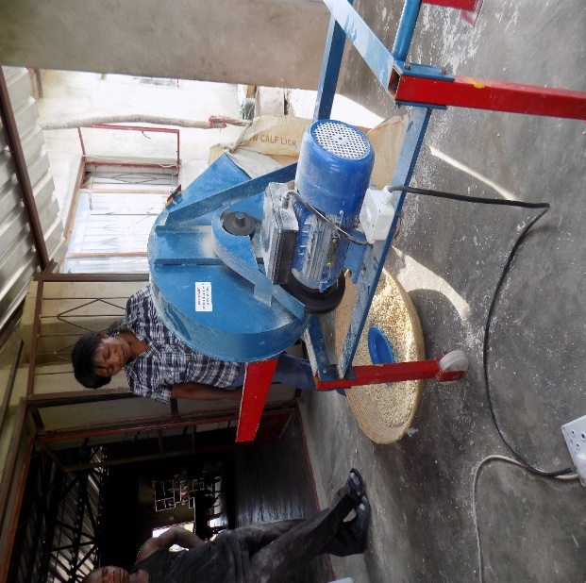
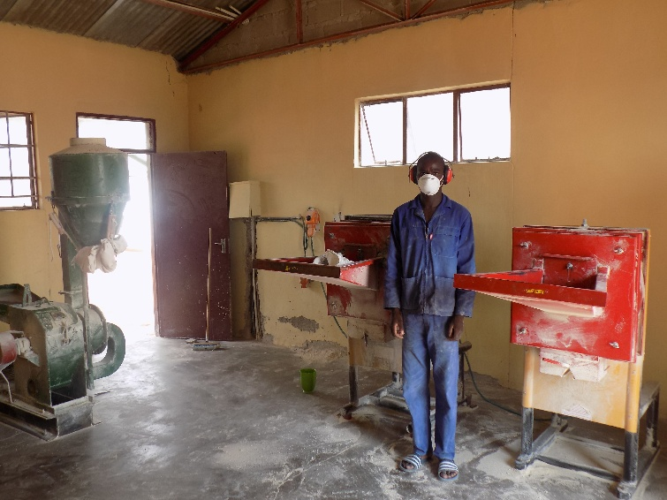
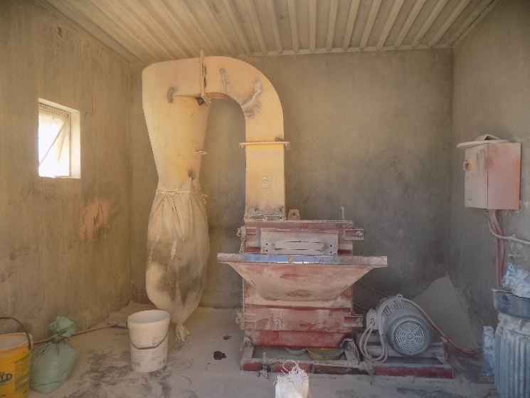
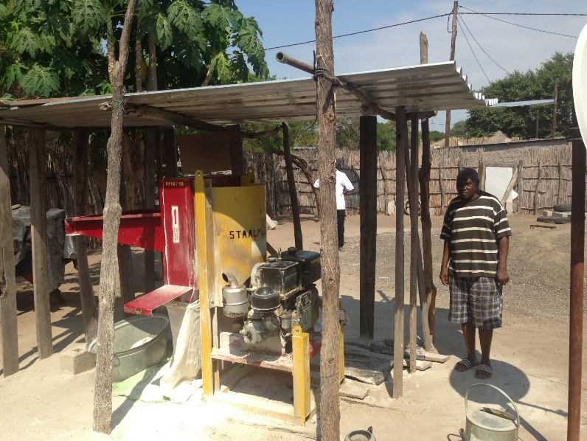
Photo 2: An example of the different types of service mills

The exact number of milling machines driven by diesel engines has not been ascertained but they exist in all the regions. Table 4 only shows the power sources of the mills visited.

Table 4: Hammermill power sources
Region | Electric Driven | Diesel Engine Driven* | Total
Zambezi | 7 | 5 | 12
Kavango East & West | 7 | 3 | 10
Oshikoto | 8 | 2 | 10
Omusati | 8 | 2 | 10
Ohangwena | 8 | 2 | 10
Oshana | 4 | 1 | 5
Total | 42 | 15 | 57
Percentage | 74% | 26% | 100%
*The Sanku dosifier uses an electric motor to mix the cocktail and the mahangu before processing. Therefore diesel driven mills will require a source of electric power to drive the dosifier. This is an additional attachment that will mean an additional cost.
Four of the small-scale commercial mills visited had roller mills in addition to their hammer mills. The small scale commercial mills housed one to five milling machines in one building. In addition some service millers owned two to three hammermills at different locations in each of the regions. These differences affect the type size and quantity of dosifiers that has to be used by the various service and small-scale commercial mills. They may be need to classify the mills and couple them to a suitable dosifier.
On the market there are several types and sizes of dosifiers. However, for the discussion in the FGMs an example of the Sanku dosifier was used owing to the fact that it is the one recommended by GAIN. A minimum blending uniformity standard is required for fortification through small mills. It is not possible for small holder millers to achieve that tight uniformity standard (i.e. within 10% of a target Recommended Daily Allowance dose) using any other known dosifier. In 2014, after three years of rigorous testing, GAIN officially approved and recommended the use of the Sanku Dosifier for small and medium scale applications. GAIN ascertains that the Sanku Dosifier has been specifically designed to overcome dosing accuracy, cost, sustainability, scalability and monitoring constraints. A single Sanku dosifier costs US$2000.00 before import and transportation expenses are included.

Dosage and Dust created by the Cyclone
The cocktail is technically a pre-mix meaning it is added to the mahangu before it passes through the hammermill. A typical Drotsky M16 has cyclone effect and do not recover 100% of the processed flour. A tiny amount of processed flour is lost in the form of dust due to the cyclone effect. Therefore any application rate (dosage) of the cocktail should take into consideration these losses to ascertain whether they do not alter the Daily Recommended Allowance dose of the fortified mahangu.

Turnover Variation
There is high variation in the turnover of service mills, e.g. one mill processes 50 kg per day while the other can process up to 1000kg in a day. On the other hand milling business is seasonal, it has peak periods and times when very little amounts of mahangu are processed. Some millers service a bigger market whereas the others have a very small market. This determines the amount of grain a mill processes over a given time. Throughput of a mill also depends on the location and other market related factors such as the price of the service, time of the year, customer care, etc. This eventually reflects on the profitability of the different mills and their ability to payback a loan. Service and small scale commercial mills have got highly variable daily/monthly throughputs therefore capital to fund the dosifier and/or fortification should consider the different levels of profitability of these businesses.

Pricing
The price for milling mahangu ranges between N$10.00 and N$17.00 per 20 litre bucket (lata) in all the regions. This converts to N$0.67 to N$0.95 per kg. The mean price in all the regions is about N$14.00 per 15kg of grain. In the NCRs milling fermented grain was slightly cheaper than unfermented. Millers with hammermills driven by diesel engines charge higher rates and they attribute it to the cost of fuel and maintenance of the engine. All the FGMs were concerned that an increase in the price of milling would reduce the number of their customers which would lead to low profit on their businesses. They were of the opinion that some of their clients may even resort to traditional ways of pounding mahangu if the price increase is beyond what they can afford. A maximum increase in price of N$3.00 per bucket was believed possible. This would on average raise milling price of a bucket to about N$17.00. Millers felt that price increase would slow down their business at the beginning with chances of it picking up later.

Financial Implications
Assuming the service or small-scale commercial millers are making reasonable profit before fortification is introduced, then the following tables (5 and 6) illustrate the additional costs and income from taking up fortification. The other assumptions are the millers make an arrangement with a financial institution for a loan to finance the purchase of the dosifier and the loan is payable over a period of five years. Two scenarios are presented; one where the miller deposits N$2440.00 (10% of price) and the other N$3660.00 (15% of price). The additional cost in scenario one where the millers deposits 10% of the cost of the dosifier is N$1.36 for processing 15kg (20l) grain and this converts to N$0. 09/kg of grain. In scenario two the deposit advanced is N$3660.00 and it costs N$1.23 to process 15kg mahangu grain or N$0.08/kg.
The cost of importing and transporting the dosifier to the site for installation is not included in the calculation. The Sanku dosifier used in this illustration uses an electric motor to distribute the cocktail equally over the grain before the milling process. Therefore electrical installations to synchronize its operation with the operation of the existing hammer or roller mill may be required. It may be negligible since this involves connecting two or three electrical wires to the switch of the existing hammer mill. The cost is not included in this calculation. Diesel engine driven hammer mills will require either a solar assisted system or a generator to operate the dosifier. The cost of that is also not included in this calculation and a rough estimation of the total number of diesel engine driven mills is given in table 4 as 26% of the total estimated mills in the northern regions.

Table 5: Cost of fortification (fortification component only)
ITEM | DESCRIPTION | AMOUNT (N$)
Cost of Dosifier (US$2000.00) |  | 24400.00 | 24400.00
Less deposit (10% and 20% respectively) |  | 2440.00 | 3660.00
Principal Loan Amount |  | 21960.00 | 20740.00
Loan Period |  | 60 months | 60 months
Total interest @ 9% p.a. |  | 4792.19 | 4193.16
Dosifier repayment/month (9% Interest) |  | 405.20 | 354.55
Additional Electrical bill/month |  | 30.00 | 30.00
Cost of cocktail/month | 22 days x 300 kg xN$ 0.018 | 118.80 | 118.80
Total |  | 543.20 | 492.55
Cost/day (22 work days per month) | 543.20/22 | 27.16 | 24.63
Cost/kg (300kg milled per day) | 27.16/300 | 0.09 | 0.08
Cost/15kg (20L Tin) | 15kg x N$0.09 | 1.36 | 1.23

The additional income generated from taking up fortification as a miller are illustrated below in table 6 below. The last two columns indicate additional income from the different levels of grain processed in a day at a service or small-scale commercial mill. If an average daily turnover of 300kg per day used in the fortification costing above (table 5) is compared to the monthly additional income from processing the same quantity of grain (N$721.60/month), the miller will be able to pay back the loan at 10% deposit and remain with N$316.40 monthly gross margin. In this margin other additional logistical costs like transport to buy the cocktail will have to be deducted. However, after repayment of the loan the miller can make approximately N$721.60 gross profit. The profit margin is slightly higher where a 15% deposit is advanced during purchasing of the dosifier.

Table 6: Additional income from fortification
Grain processed/day (kg) | Current Mean Price (N$/15kg) | Fortification cost (N$/15kg) | Approximate Mark up  (N$/15kg) | New Price (N$/15kg) | Daily Additional Income(N$) | Monthly Additional Income (N$)
225 | 14.00 | 1.36 | 1.64 | 17.00 | 24.60 | 541.20
300 | 14.00 | 1.36 | 1.64 | 17.00 | 32.80 | 721.60
375 | 14.00 | 1.36 | 1.64 | 17.00 | 41.00 | 902.00
450 | 14.00 | 1.36 | 1.64 | 17.00 | 49.20 | 1082.40

Cost of Acquiring the Dosifier and Cocktail
If considered desirable the cost of buying dosifiers for the service and small scale commercial millers is shown in table 7. Multiple mill ownership has been factored into the estimations. However, the cost of acquiring either generators or solar panels to cater for the diesel engine powered mills is not included in table 7. Approximately 234 mills will require solar panels or generators to power the dosifier.

Table 7: Combined cost of required dosifiers
Cost of Dosifier | Small-scale Commercial millers | Service millers | Total
US$ | 144,000.00 | ±1,800,000.00 | ±1,944,000.00
N$ | 1,756,800.00 | ±21,960,000.00 | ±23,716,800.00

Once the dosifiers are up and running a constant supply of the cocktail will be required. To make the calculations easy, this study looks at one year (initial) supply of the cocktail which will enable easy future procurement projections. Assuming a normal rainy season an average quantity of grain processed by a service mill in a day could be 225kg. The dosage of cocktail is based on maize meal vitamin cocktail rate of 0.2kg/t (Namib Mills). Table 8 below illustrates the quantity and cost of the cocktail required over a period of a year. The cost of transportation from South Africa to Namibia is not included.

Table 8: Quantity and cost of cocktail
Type of Mill | Grain Processed (t) | Cocktail (kg) | Cost (N$)
Small-scale commercial | ±1000 | ±200 | 18,500.00
Service | ±53,000 | ±10,600 | 980,000.00
Total | ±54,000 | ±10,8692 | ±1,000,000.00
Notes: 1. Amount of grain processed by the service mills is based on a rough daily average of 225kg and a 22 monthly work day schedule obtained from the field estimates
2. No accurate figures were collected from the small-scale commercial mills therefore an assumption was made that one fifth of the mahangu commercially milled was coming from the small-scale commercial mills.
3. The cost is based on DSM Nutritional Products, South Africa maize cocktail ex-stock price of N$2304.00 per 25 kg

Maintenance and calibration
Fortification equipment will require back up services in the form of skills and spare parts for repairs to accommodate wear and tear or break downs of dosifiers. Periodically the dosifier may under or over apply the cocktail as it can slowly go out of setting with use. Therefore periodic recalibration will be required to ensure accurate application of the cocktail.

Structural soundness of some mill housing and hygiene
The mill houses are of various standards and structural soundness. A significant number of service mill houses lack appropriate hygienic standards to entrust them with storage and adding the cocktail in public mahangu. This situation is more pronounced in Zambezi and to a lesser extent in Kavango regions. About 20-30 % of the mills visited need an upgrade structurally. The mill houses will benefit from regular inspections to ascertain hygiene standards are kept at acceptable levels.

Cocktail Supply chain and Storage Issues
The supply chain needs to be managed, that means starting from inventory planning, procurement of the cocktail, transportation into Namibia, re-packing into suitable packs, creating distribution points and storage. Sustainability of the supply chain, monitoring and adjustments to respond to the prevailing needs of the millers and market conditions will need to be established. At this point in time the source is known but all the other logistics are not in place. There is an indication in all the regions that one or two small-scale commercial millers are will to act as distribution points and sell the cocktail to the service millers.
The cocktail has a limited shelf life, therefore mechanisms to ensure that expired products are not sold to the millers need to be put in place. Practical positioning of this role to an organization and costing of the operations involved will be important.

Baseline Information
Currently it seems there is no updated information regarding the statistics of child stunting and malnutrition in Namibia. It is imperative that the degree to which mahangu fortification will change the stunting statistics be monitored to enable evaluation of the impact of the intervention over the years. Therefore there is need to obtain accurate data on the status of stunting or micronutrient deficiency in the northern regions of Namibia. If fortification is allowed to go ahead without obtaining this data, evaluation of the impact on the communities will remain uncertain.

Implications of QC and monitoring
Quality control creates the need to monitor the product that is processed from the hammermill from time to time to ensure that the desirable addition of the vitamins and minerals is achieved. In other words quality control of the milled products need to be put in place. That role should be institutionalized and the costs involved should be passed onto that organization.

Social Implications
Knowledge on fortification and malnutrition was very scarce, very few millers fully understood what is involved in food fortification and the reason for it. After explaining all the millers welcomed the idea of food fortification. However they raised a pre-condition that should be met before fortification can be accepted.
All service millers alluded to the fact that introducing fortification without making the community aware of the benefits will create problems of acceptance at the mill. It is not easy for their clients to conceptualise the idea of some substance added to their milled product. A range of perceptions will come into their minds and milers gave examples: some may think they are being forced to take ARVs, some may think they are being poisoned and many other thoughts especially if the colour and taste of the meal is altered. Therefore because of these conceptions the millers felt a thorough awareness campaign has to be carried out before embarking on fortification at service mills. They felt if well explained and understood by the communities, fortification may be accepted since no person would want their children to be sick due to deficiencies in micro- nutrients.
The service millers expressed that awareness campaigns or educating the communities should not be left to the millers only, NAFIN or MOHSS must pave the way. Involving the Traditional Authorities, Regional Council, headmen and experts from various stakeholder institutions in the awareness and training of the communities was considered necessary. This should complement radio, TV and poster campaigns.

Training
The millers expressed the need for technical training in the use of the dosifier especially for the mill owners and the operators. They viewed training of the mill owners as key to fortification since operators come and go but the owners should be in a position to train the new operators whenever one operator leaves. Important areas to be covered were:
- Technical set up and operation of the dosifier
- Basic maintenance of the dosifier and the hammer mill
Secondly, millers felt the owners and operators need to be trained to understand the background to food fortification so that they are in a position to convince their clients of the advantages of food fortification.
They suggested initial training then follow up training to ensure that the correct use of the machine is adhered to. If possible it was suggested that the communities need information they could use for verifying that the operators were applying the correct amount of the cocktail. Thus they need training or awareness and information of what is involved in fortifying.

Making Mahangu Fortification Compulsory
The millers welcomed making fortification compulsory but were worried as to whether there will be no stringent mill housing structural and hygienic standards required of them, in order to fortify in compliance with government regulations. Therefore, if fortification is to meet certain standards that will require upgrading of their mill houses, assistance to upgrade will be required. Services miller were of the opinion that if fortification should be taken up, then all should be forced to fortify. Their reason is that the customers may end up migrating to those who offer lower prices for processing grain due to non-application of the cocktail and they will lose business.

Namib Mills
A visit to one commercial miller in Windhoek revealed that the cost of fortifying maize was reasonable such that they were not even passing the cost to the consumers. The greater cost came from acquisition of the dosifier and they had an in-built way of recovering the capital cost of this piece of equipment. Currently Namib Mills fortify their maize products and Meme Mahangu is yet to be fortified. As there is no legal framework and fortification standards developed for the Namibian market, Namib Mills uses the South African standards to fortify the maize products. The cocktail is also supplied by a South African Company.

Concerns
Millers expressed concern over the high cost of the Sanku dosifier which was presented to them as an example. This example was used since it is the mixer recommended by GAIN and is in use in other African countries.
Some millers were worried about the side effects that would be caused by the fortification ingredients. Allergies were singled out as a potential threat to their business, in the case someone develops some allergies after taking a meal prepared from fortified flour.
They also wanted clarification on what would happen to the nutritional status of the consumer if fortified mahangu meal and maize meal are blended.
Millers wanted to know the benefit of all the additional management tasks that come with fortification in view of the service milling price that is almost inelastic.
Millers also wanted to know the reason for investing in a machine that would not bring in significant profit to their businesses. Therefore they suggested that the government should take greater responsibility in the investment since the goal is to achieve good public health.

Conclusions from FGMs
It is technically possible to fortify mahangu at the service and small-scale commercial mill level in the northern regions of Namibia. However, they are logistical, technical and financial issues that will need to be overcome as is described above in this report. Furthermore the legal framework in which fortification is to operate should be clearly defined and organizations that will enforce and monitored the process identified and fully funded to enable them to carry out their mandate.
Initially service millers will need assistance financially to set the scene rolling since the financial projections indicate a not so profitable venture from a business point of view. The millers indicated that they are not prepared to fund fortification on their own given the fact that financially it does not sound extremely profitable while there is added responsibilities and activities on their businesses. The cost of the dosifier was identified as the major bottleneck as it is too expensive. Millers did not have any problem fortifying mahangu using a cheaper alternative to the Sanku dosifier.
Support services to maintain and repair the technology came out as an issue that will need serious consideration if fortification at service and small-scale commercial mills is to be sustainable. There will be need for skilled personnel to carry out routine maintenance and repairs. Spare parts supply and availability within a reasonable time and at local shops should be considered.
Supply chain logistical management of the cocktail is currently not there, therefore it needs to be established and allowed to develop so that it can respond to the demands of the millers and the market. A reasonable source of the cocktail should be identified, re-packaging facilities established and distribution and storage put in place. In addition monitoring system of the shelve life of the cocktail will be required.
Community education, awareness campaigns and training of the mill owners and operators should be given attention before the programme kicks off. This should continue for the unforeseeable future until the uncertainties associated with fortification disappear.
Quality control of the product coming from the mills will need periodic monitoring to ensure correct application of the cocktail is being adhered to. The enforcing organization should be equipped and funded to ensure millers participating in fortification are managing the cocktail well.
Small-scale commercial millers viewed fortification as value addition to their product, therefore they present an opportunity to pilot fortification given that they do both service milling and flour packaging. They were not so much concerned about the price of the dosifier, all they wanted was some form of assistance to get loans and subsidies to finance the dosifier.
Service millers preferred fortification to be compulsory as they feared loss of business should some millers remain milling without fortifying. Their argument is that if some millers do not participate in fortification, the cost of their service will be low hence customers will leave for the lower prices.

SECTION 2
Feasibility and Possible Way Forward
This section examines the feasibility of mahangu fortification based on the findings of the field work and consultations as reported above, while looking at the “broader picture” of cereal grain consumption in Namibia. The section also explores different options for mahangu fortification as possible way forward. The consultants do not arrive at a definite recommendation but highlight the pros and cons of the different options suggested.

Coarse Grain Consumption and Mahangu Production in Namibia
The Namibia Early Warning and Food Information Unit (NEWFIU) of the Ministry of Agriculture, Water and Forestry indicates an annual national cereal consumption for food use around 260’000 tonnes in 2013/2014 and an estimated 272’000 t for the 2014/2015 marketing year (May to April). The 2014/15 estimates are not yet finalised, and an average of 265’000 t of cereal grains consumed per annum is retained in the rough quantification presented below.
Still on an annual average, maize represents around 132’000 t (50%), mahangu (and sorghum) around 68’000 t (26%) and wheat around 65’000 t (24%). Maize and mahangu (+ sorghum) combined represent around 200’000 t with the annual maize consumption varying significantly according to the annual mahangu harvest. Maize meal is the main substitute to mahangu flour in years of mahangu scarcity, although wheat products are becoming more and more popular.
The national cereal production statistics (NEWFIU) indicate a 15-year average mahangu production around 60’000 t (and 8’000 t for sorghum) with huge annual variations for mahangu from a low 35’500 t in 2007/2008 to a high 105’800 t in 2005/2006.

Mahangu milling
Mahangu commercially milled represents around 6’000 t per annum of grain equivalent (so around 5’000 t of flour assuming a 15% milling “loss”). In an average year, 1’000 t of mahangu grain is purchased locally and 5’000 t is imported, mainly from India. The main commercial mahangu miller processes around 4’ to 5’000 t while the small scale mahangu commercial millers process around 1’ to 2’000 t.
Commercial mahangu flour is more expensive than maize mealie meal, and this would suggest that mahangu flour is mainly purchased by “wealthier” urban traditional mahangu consumers although no statistics were at the disposal of the Consultants to quantify it. Though, the “rural” consumption of commercial mahangu flour does not appear to be insignificant, particularly in the North Central Regions (NCRs).
Nevertheless, the bulk of the mahangu flour consumption originates from the domestic production. The proportion of the household consumption of mahangu flour that is processed in service mills (versus processed at home) is not known accurately. However, (guess) estimates vary between 60% and 90%. With this large bracket, it would mean that between 36’000 t and 54’000 t of mahangu grain-equivalent is annually milled by service millers, say around 45’000 t (75% ?) per year on average (or 38’000 t of mahangu flour processed by service mills) with likely important variations between years of good mahangu harvest and years of drought (or floods).
It must be noted that service mills are not evenly distributed in the northern Regions and rural inhabitants in remote areas do not all have an easy access to a service mill, especially in non-electrified areas where service mills (run by diesel engines) are less frequently located. Furthermore, the number of service mills in the two Kavango and the Zambezi Regions, as compared to their populations, is much lower than in the NCRs. It must also be noted that in these three Regions, the service mills also process maize grain for customers. Importantly, it is to be recorded that nearly all small scale commercial mahangu millers also provide service milling in their business premises.

Options
Four different options are examined below with their pros and cons, particularly focusing on their potential impact in reaching consumers, their respective challenges (technical, logistical, financial) to be addressed, and in fine their potential cost/benefit level in qualitative terms. An accurate quantification of costs versus benefits will be complex to elaborate and any results would probably remain plagued by a high degree of uncertainty on both costs and benefits.

Option 1: Status quo
No specific intervention towards mahangu fortification is to take place. It would mean that the current fortification of maize meal and bread flour voluntarily conducted by Namib Mills and few other smaller maize millers is considered the best that can economically be performed in the Namibian context.
[The details of the fortification implemented by Namib Mills could be given here, if needed.]
The status quo option may not be considered satisfactory in view of the nutritional challenges faced by the Nation, but at least it represents a significant contribution to the fortification of two of the main staple foods widely consumed in Namibia, at a negligible cost to the State coffers.
Two sub-options are suggested but they are beyond the specific scope of this consultancy.
- A more pro-active promotion of the fortification of maize meal towards the maize millers who do not fortify despite the existing subsidy scheme for procuring a pre-mix (cocktail) dosifier/mixer. The justifications of such action are that maize meal remains the main staple food consumed in the country and all maize meal should be fortified, while the number of maize millers to be involved is limited.
- Investigate the fortification of other products widely consumed in the country, such as cooking oil and lipid spreads, dairy products, cake flour, drinks?

Option 2: Fortification of mahangu flour by commercial millers only
The small scale commercial mahangu millers reacted positively to the idea of voluntary fortification but with a subsidy contribution from Government and technical back-up. However, even if Namib Mills were to fortify its Meme Mahangu products, the impact in volume of fortified mahangu flour sold will be limited (i.e. around 5’000 tons per year, around 10% of the total mahangu flour consumption on average). Nevertheless, the foreseen technical, logistical and financial challenges of such scheme should be manageable on account of the limited number of commercial mahangu millers (currently 18 small scale and 1 large scale).
Fortification by commercial mahangu millers may have to be regulated (and made compulsory). An issue to be perhaps discussed in the envisaged “final consultation” workshop that was planned to conclude the first phase of this consultancy.
The mahangu fortification at the level of small scale commercial millers, voluntarily or regulated/compulsory, could constitute a pilot phase before considering its extension to service millers. As noted above, these small scale commercial millers are also provider of service milling and the impact could probably be doubled (if not more?) while generating a wealth of practical information and experience before any upscaling to the other 900 or so service millers.

Option 3: Promotion of voluntary fortification of mahangu flour by service millers
The promotional efforts may have to be substantial (and costly) in view of the general reluctance of service millers to voluntarily engage in fortification unless substantial subsidies and technical support are committed. The uptake rate will remain unknown in advance, which will be a major difficulty in planning and managing such scheme.
However, a pilot scheme could be envisaged in one Region or in few limited regional areas in order to gauge such scheme in terms of information and communication needs, technical and logistical challenges, organisational requirements, subsidy levels, impact and uptake rate etc.

Option 4: Regulated and compulsory fortification of mahangu flour by all millers
This option would have the largest impact theoretically since mahangu flour processed by service mills represent the largest portion of mahangu consumed. However, two major obstacles are foreseen: (i) not all service millers have the appropriate milling facilities suitable for quality fortification (lack of space and storage etc.) and would not be compliant to such regulated scheme with the implication that either they would drop the service milling business or continue illegally, and (ii) the launching and subsidy costs will be very high (estimated at a minimum of N$20-30 M) and the annual recurrent costs for monitoring, inspecting and enforcing, re-training and providing technical back up would be probably prohibitive.
Besides the issue of costs, it remains unclear which Namibian body/ies mandated with the responsibility of enforcing the regulation and monitoring compliance will have the qualified human resources to be deployed nationally. In this regard, the South African experience (as reported in “Monitoring of Flour Fortification: The Case of South Africa” UNICEF & Food Fortification Initiative, 2014) suggests two different levels of inspection and monitoring. The inspection and monitoring of compliance on the one-hand, and the quality testing in the final products on the other hand. The report also highlights interesting lessons learnt from the country’s experience, not all necessarily relevant to the Namibian context and to fortification at the level of service mills, which is not conducted in South Africa.

In conclusion of this draft report, the Consultants cannot formulate a definite recommendation on the four options presented and seek guidance from the NAFIN Fortification Working Group steering committee on the way forward.

Appendix 1: Check list for FGM
Check list for Mill owners Focus Group Meetings
- Knowledge about food fortification and nutritional Issues
  - What do you know about food fortification in general?
  - What is the purpose of food fortification?
  - What kind of food do you know is fortified in Namibia?
  - Is there any other food that could be fortified, if yes please specify?
  - Are you aware of stunting problem?
  - What do you think about it?

- Attitude towards food fortification and consumption of fortified food
  - What is your perception toward food fortification, for example your perception towards iodized salt?
  - In your opinion is it a positive or a negative thing? Please explain why.
  - What do you think about other food fortification?
  - What other food could be fortified?

- The role of service millers in mahangu/maize fortification
  - How can service millers facilitate mahangu fortification?
  - What facilities and equipment will you need?
  - Is there enough space for additional equipment in your mill housing?
  - If you are to be a mahangu fortifier where would your store the cocktail?
  - What else would you require to make fortification service a success?
  - Are you willing to provide fortification service to the community?
  - How do you intend to acquire the equipment and cocktail?

- Effect of increased milling price due to fortification
  - What is the current service fee for milling 20kg (Lata) of mahangu/maize?
  - What will happen if you increase the fee with N$0.50, N$1.50, N$3.00 or N$5.00 to account for fortification?
  - What impact will fortification have on the business profitability and customer base?
  - At what price level will you be willing to buy fortification equipment?

- Keeping track of cocktail use
  - What is your daily milling throughput? (per day, monthly)
  - What mechanisms are there to authenticate your figure?
  - How are you going to ensure that the mill operators are using the correct dosage of the fortification cocktail?
  - Do you think training is required for proper mixing of the cocktail?
  - Who should be trained? Why?

- Informing the population about mahangu/maize flour fortification
  - In your opinion, should people be informed about food fortification? Why?
  - Do you think fortified mahangu meal is going to be easily accepted by the communities?
  - What means of communications for effective dissemination of such information could be used in your region (radio, posters, schools, newspapers, printed materials, TV, etc.)?
  - Why do you think these means of communications would be effective?

- Who should disseminate flour fortification information
  - Which persons would most effectively disseminate the information? (Specialists, famous persons, government representatives, community leaders, politicians, healthy workers etc.).
  - In what format (oral, written, role plays, posters, etc.) should this information be presented to the general population?

- Proposed messages by participants for flour fortification
  - What would be an effective short message that would grab the attention of millers to stress the importance and benefits of flour fortification?
  - What would be an effective short message that would grab the attention of your customers and the general population?

- Opportunities and Sustainability
  - Do you see fortification benefiting the milling business?
  - What are the perceived benefits do you foresee?
  - What challenges/problems will fortification bring to the milling business?
  - In your opinion what could be done to minimize the challenges?
  - Do you think fortification can be self-sustaining? Why?

- What other ideas or suggestions on mahangu fortification do you have?

Appendix 2: List of Service Millers who Attended FGMs
Zambezi Region
No | NAME | Contact Number | VILLAGE | Visited
1 | J. Bafumisi | 0812537527 | Kongola | x
2 | P. Kasweka | 0810390880 | Kongola | x
3 | Liemo Mbangwate |  | Makanga
4 | Cathrine Champa |  | Sibinda | x
5 | Linus Mulisa | 0818683326 | Linyanti | x
6 | E.C Sibeso | 0818683326 | Linyanti
6 | L. Muchila | 081474471 | Chinchimani | x
7 | L, Silumbu |  | Chinchimani
8 | B. Kulobone | 0813188607 | Kanono | x
9 | I,Mahoto | 0812626831 | Kanono | x
10 | Z. Nalisa |  | Lusu
11 | Mangena |  | Masokotwane
12 | Oscar Khamo | 08138514449 | Sikanjabuka | x
13 | Manson Chizabulyo |  | Iseke
14 | Joseph Kalokela |  | Iseke
15 | Reckie (M. Legge) | 0814516975 | Bukalo | x
16 | M. Mushabati | 0812465473 | Ngoma
17 | C. Matengu | 0815654079 | Bukalo | x
18 | C. Sisamu |  | Lusese
19 | G. Simata |  | Kabe | x
20 | M. Muhulume | 0817632767 | Kabe | x
21 | Emelda. Inyambe |  | Impalila
22 | Lovemore Utambo |  | Katima Urban
23 | S. Sitali Limbo |  | Batubaja
24 | D. Ziezo |  | Mwanzi
25 | Dorothy Maseke | 0813825585 | Napengo
26 | V. Siemo | 0813310004 | Kaenda
27 | L. Mun’oli |  | Kaenda
28 | Jolasi Twawilwa |  | Sachinga
29 | B. K Lielelo |  | Kasheshe
30 | Imelda Nyambe | 0812917844 | Impalila

Kavango Regions
No | NAME | Business/Institution | Contact Number | VIsited
1 | Sikongo Josef | Eparu Milling | 0816210867 | x
2 | Kupembona Augustinus | Bunya aka Sambusa milling youth projects | 0812373799
3 | Lengembe Mathew | Remeba Mills | 0813505593
4 | Kamanga Runelu | Katsitvakatsi | 0812773879 | X
5 | Gidion Ashindi | Nangali Milling | 0812266129
6 | Magadelina Namwandi | NRCS, Rundu | 0812127475
6 | Immanuel K | Kavango mahangu | 0812066129, 0812981651
7 | Kasomo P. Haita | Sivara Mills | 0812433752
8 | Mathias Muronga | Samunkosa mills | 0814447540, 0812845416
9 | Lucas Makayi | Kayengona | 0812947102 | x
10 | Heria. L. Siteketa | Singoimba Mills | 0813388445
11 |  | Kaguni | 0812076292
12 | Muremi Nimrod | Satoka Sage | 0811248397
13 | Tolori Immanuael K | Uhwiwanga | 0812284682
14 | Ntusi S. Erastus | Ntusi Trading Investment cc | 0818032510
15 | Kandereyi P | Mupini | 0813138851
16 | Hamukwaye Elizabeth | Mupini | 0813600483 | x
17 | Neto Likoro | Shayeka Kutwa Milling | 0811243948
18 | Mukuya Christof | Shanyashi Mills | 0818250824
19 | Ninyemba Mbambi | Mill 20 Milling | 0812028516
20 | Mukuve Laurensia | Dudu Milling | 0813387886
21 | Muronga M | Rundu Rural Constituency | 066 256230
22 | Amadhila N | Pombili Hammer mill | 0813142675
23 | Tovoro C. O | Tusetekenu Milling | 0812917701
24 | Mizzis. L | Tusetekenu Milling | 0816244443
25 | Haikera F | Mantarangera Milling | 0814043516
26 | Klaudia Nyundu | Mantarangera Milling | 0814283706
27 | Kamalanga Elizabeth | Kangesi Milling  Kavangu Milling | 0812981651

Oshikoto Region
No | NAME | Business/Institution | Contact Number | Visited
1 | Lena Samadhi | Mukwangombe milling | 0812014225
2 | Abraham Negumbo | Ananke taanongona milling | 0812168503
3 | Anna Uudhila | Heroes Trading Enterpise | 0812517955
4 | Rauna Ndokoho |  | 0812879450
5 | Justina Ngolo Shigwedha | Isara Mahangu | 0813230019
6 | Kathima Jossef | Ndapewa | 0813131581
6 | Jakob Nakaleke | Onyaanya constituency | 0812737298 | x
7 | T. Johannes | Rosanya J | 0812300761
8 | Mateus Nekwinya | Takatsu Milling | 0812345651
9 | Dila Tomas | Takatsu Milling | 0816852724
10 | Lydia Nampweya | Malenga Project | 0813072935
11 | Paulina Halwendo | ABC Mahangu milling | 0811270789/0816487434 | x
12 | Silas Shikongo | Salmon Mill Project | 0812114633
13 | George. A. Itembu | Ekondombolo | 0811270246
14 | Simon Sheya | Oshinangeta mill | 0814306207 | x
15 | Pinias Tomas | Tatsu Oshipi | 0812559851 | x
16 | Sem Shipena | Nandepa Oshini | 0813328401
17 | Selma Egumbo | Mede Milling | 0816996308
18 | Helena Nekomba | Elago | 0811284364
19 | Delila Ashitela | Omuntele ORU | 0812313441
20 | Barkias Samadhi | Mukwanangombe | 0812352632
21 | Fillemon Johannes | Heleni Investments | 0813455751
22 | Saima Nghitelwa | Heleni Investments | 0812131277
23 | Peter Nandjendja | Onkugo-yepongo | 0812592082
24 | Elizabeth Shiponeni |  | 0813349985
25 | Selma K Nakajiko | Summy Mahangu crusher | 0812577515
26 | Erusmus Shikonda | Oshin | 0811245126
27 | Eino Ndashe | Ekunatho | 0812875013
28 | Joseph Kakungha | Omithu | 0812450719
29 | Teopolina Amupolo | Kuku Kaenda | 0813065345

Omusati Region
No | NAME | Business/Institution | Contact Number | Visited
1 | Martha Angala | Namib mills | 0812837088
2 | Augusta Ekandjo | Oshini | 0812560985
3 | Sarah Shikongo | Meme Mahangu | 081479990/0812695050
4 | Nekulilo Shikwambi | Oshini | 0816039986
5 | Simon Shetunyanga | Onakaheke | 0812607141
6 | Erusmus Indongo | Oshafuluka Milling | 0812707974
7 | Regina Itenge | Kanikanayi | 0814900201
8 | Johannes Iiyambo | Ondjola milling | 0812574435
9 | Philipus N Kashima | Regional Council | 0811286945
10 | Ishitile M. Ruben | Okakuro | 0811297040
11 | Ekandjo Festus | Tutsine Pamwe milling | 0813097656 | x
12 | Martin Iita | Tsandi Trading | 0812742062
13 | Ndilinowa Petrus | Omusipinoshaye milling | 0814781446 | x
14 | Alina N Paulus | Oshini | 0812176377

Ohangwena Region
No | NAME | Business/Institution | Contact Number | Visited
1 | S. Kaandje/Nakaambo | Omalambo | 0812805375
2 | Robert Nghiyoonianye | Onhungila mahangu mill | 0812805715
3 | Veronica Hamutenya | Kelina Trading Enterprise | 0812301050
4 | S.P Haimbangu | Kelina Trading Enterprises | 0812224088
5 | Jomas Mwandingi | Omupanda | 0812514574
6 | Linus Shiyova | WE2 | 0811224468
7 | Natanga Alfeus | Oshaango Trading | 08145111763
8 | Muujao Tomas | Tukwatha | 0814857181
9 | Titus Usiku | Onangolo | 0813097151
10 | Fillipus Daniel | Oshipala | 0812505193 | x
11 | Olivia Dumeni | Unlimited Adventure | 0816572531 | x
12 | Ndipwashimwe Andreas | Kadila Project | 0813037514
13 | Shilomboleni Jona | Kig of Kig | 0812402839

Oshana Region
No | NAME | Business/Institution | Contact Number | VIsited
1 | Hon Vinia Abaai | - | 0812309259
2 | Shomangula Olavi | Oshini | 0812465531
3 | Peter P. Iita | Oshini | 0812558574
4 | Julia Shivolo | Oshini | 0813005926
5 | Aina Shipombo | Shalongondaile | 0812315422
6 | Josephati Awene | Apaka Trading | 0816733659
7 | Sakalia Iindombo | Kambweshe bar | 0813194422
8 | Nikodemus Shilongo | Oshini | 0812320987 | x
9 | Maria Angula | Oshini | 0813165854
10 | Sylivia Shuumbwa | Nande Omahangu Mills | 0812553098
11 | Willem Aukawa | Oshini | 0812414767
12 | J. Muhwitha | Women Mahangu | 0812787984
13 | Agrippa Shilongo | Uungwanga Mills | 0812503125
14 | Johannes Mpinge. A | Aakwela Mill | 0811487455
15 | P. A. Shilongo | PAA Mills | 0811278021
16 | Josef Moses | Peaceful Mill | 0811278021
17 | Hendrina Shipiki | Mahangu Crusher | 0811494234
18 | L. K Shihepo | Yavo Oshini | 0851287719
19 | Steve Biko Nghi | Ohangwena Mills | 0812631850
20 | Rauna Nakasole | Takatu Mills | 0812735668 | x
21 | Haipinge | Okandambo | 0812334578
22 | Johannes Neshindo | - | 0812072818
23 | Albertina Endjala | Iinko Investment mills | 0813577642
24 | Isak Nakashwa | TJI Mahangu Mill | 0812979255
25 | Silas Kandenge | Oshitowa Mahangu Mills | 0813166787
26 | David T. Kumbi | Mahangu Mills | 0814828667
27 | Gerhard Pineas | Ileni Tusteni | 0812560991
28 | A.N. Shapaka | Mahangu Mills | 0812888458
29 | Abisai P. Shikonga | ABC Okapya | 0811293513
30 | Joali Damindi | Paladisa | 0811285436
31 | Shigwedha | Shinjemba
32 | Lusias Gideon | Kadhila | 0812792684
33 | Matias Angula | Ehumahuma | 0811414955/0812009024
34 | Charles J. Hangara | Oletu Foods mahangu Project | 0812947702 | x
35 | O. T Neshuku | Oletu Foods mahangu Project | 0812736598
36 | E. A. Shivute | Elilio Mahangu | 0813000325
37 | R. Sheyavali | Power Friends | 0818554228
38 | J. Mutiwtha | Woman Mahangu | 0812787984
39 | Absalom A | Oshini | 0816489650
40 | Inkono F.M | Opoto mills | 0812481285 | x
41 | Emelita Kuurondo | Mahangu mills | 0814044752
42 | Selma Mutota | Hammer Meal | 0812520089
43 | Maria Mashimba | - | 0812136846
44 | Kristy Shilongo | - | 0816487308
45 | Nico Aipumbu | RDC Ongwediva | 0812334374
46 | Maria Kaputu | Oshini | 0813701800
47 | Olivia Ndapuka | Oshini | 0813205533

Appendix 3: Proceedings of the Focus Group Meeting
08:45 – 09:20 | Registration | Tusnerde/Jonas
09:20 – 09:25 | Prayer | MC
09:25 – 09:40 | Introduction | MC
09:40 – 10:00 | Welcome Remarks | Hon Councillor
10:00 – 10:15 | TEA/COFFEE
10:15 – 10:40 | Background of fortification and purpose of the focus group meeting | CRIAA/NAFIN
10:40 – 11:30 | Group discussions | MC
11:30 – 12:00 | Report back on group discussions | Jonas
12:00 – 12:30 | The way forward With fortification | Jonas
12:30 – 12:40 | Selection of representative for a national fortification workshop | MC
12:40 – 12:50 | Vote of thanks | MC
12:50 – 13:00 | Prayer | MC
13.05 | LUNCH

Initially the consultant was supposed to be guided by NAB Mahangu Officers to locate the service millers in the northern regions. However, by the time the consultations took place NAB had no more Mahangu Officers in the Regions. The study approach had to be adjusted to suit the absence of the assistance initially envisaged and the addition of small-scale commercial millers as respondents.

